РЕФЕРАТ

Текстова частина бакалаврської роботи: 28 с., 10 рис., 2 табл., 3 додатка, 9 джерел.
WEB-ДОДАТОК, БАЗА ДАНИХ, ЧАТУВАННЯ, ОБРОБКА ДАНИХ,
КРЮЇНГОВІ КОМПАНІЇ, МОРСЬКІ ФАХІВЦІ, ДОКУМЕНТИ

Об'єктом дослідження є розробка веб-додатку для ефективної взаємодії між агенціями з працевлаштування моряків та морськими професіоналами. Метою дослідження є створення інформаційної системи, яка оптимізує процес рекрутингу та взаємодію між агенціями з працевлаштування моряків та морськими професіоналами за допомогою веб-інтерфейсу.
Методи дослідження, використані в цьому дослідженні, включали аналіз потреб і проблем у сфері крюїнгу, вивчення сучасних підходів до побудови інформаційних систем і веб-розробки, а також розробку і тестування прототипу веб-додатку.
В результаті був створений веб-додаток, який забезпечує ефективну комунікацію між крюїнговими компаніями та морськими фахівцями, спрощує процес найму та управління моряками, покращує доступність інформації та підвищує зручність користування.
Результати можуть бути використані крюїнговими агенціями для вдосконалення процесів найму та управління людськими ресурсами, а також морськими професіоналами для спілкування з потенційними роботодавцями через веб-інтерфейс.
Умови отримання бакалаврської роботи за дозволом проректора з
навчальної роботи ДУІТЗ.

ABSTRACT

Text part of a bachelor's thesis: 28 p., 10 figures, 2 tables, 3 appendices, 9 sources.
WEB-APPLICATION, DATABASE, CHAT, DATA PROCESSING,
CREWING COMPANIES, MARITIME PROFESSIONALS, DOCUMENTS

The object of research is the development of a web application for effective interaction between seafarers' employment agencies and maritime professionals. The purpose of the study is to create an information system that optimises the recruitment process and interaction between seafarers' employment agencies and maritime professionals using a web interface.
The research methods used in this study included analysing the needs and problems in the field of crewing, studying modern approaches to building information systems and web development, as well as developing and testing a web application prototype.
As a result, a web application was created that ensures effective communication between crewing companies and maritime professionals, simplifies the process of hiring and managing seafarers, improves the availability of information and increases user-friendliness.
The results can be used by crewing agencies to improve their recruitment and human resource management processes, as well as by maritime professionals to communicate with potential employers via a web interface.
Conditions for obtaining a bachelor's degree with the permission of the Vice-Rector for Academic Affairs of the SUITT.

ЗМІСТ

ВСТУП 11
1 АНАЛІЗ СУЧАСНИХ СЕРВІСІВ ДЛЯ ПРИВАТНОГО СПІЛКУВАННЯ МІЖ МОРЯКАМИ ТА КРЮЇНГОВИМИ КОМПАНІЯМИ 13
1.1 Опис предметної області 13
1.2 Порівняльний аналіз існуючих аналогів 13
1.3 Актуальність теми………………………………………………………………..16
1.4 Мета та постановка задач….…………………………………………………....17
2 АНАЛІЗ ВИМОГ ДО СИСТЕМИ, ЩО РОЗРОБЛЯЄТЬСЯ……………….......18
2.1 Дослідження потреб крюїнгових компаній та моряків 18
2.2 Формулювання функціональних вимог до сервісу 18
2.3 Технічні вимоги до сервісу 19
2.4 Обґрунтування обраних технологій 20
2.4.1 Firebase 21
2.4.2 Мови програмування JavaSript and JSX 22
2.2.3 Мова гіпертекстової розмітки HTML 22
2.2.4 Каскадні таблиці стилів CSS 23
2.2.5 Платформа Node.js/npm 24
2.2.6 Vite 25
2.2.7 Zustand 25
3 РОЗРОБКА ТА РЕАЛІЗАЦІЯ ВЕБ-ДОДАТКУ 27
3.1 Проектування структури проекту 27
3.2 Проектування структури бази даних 29
3.3 Розробка інтерфейсу 31
ВИСНОВКИ ТА РЕКОМЕНДАЦІЇ 38
ПЕРЕЛІК ВИКОРИСТАНИХ ДЖЕРЕЛ 39
Додаток A СПИСОК КОПІЙ ДЕМОНСТРАЦІЙНИХ МАТЕРІАЛІВ 40
Додаток Б МОДУЛІ ПРОГРАМНОЇ СИСТЕМИ 43

CONTENTS

INTRODUCTION 11
1 ANALYSIS OF MODERN SERVICES FOR PRIVATE CHATTING BETWEEN SEAFARERS AND CREWING COMPANIES 13
1.1 Description of the subject area 13
1.2 Comparative analysis of existing analogues 13
1.3 Relevance of the subject…………………………………………………………..16
1.4 Goal and objectives…………………………………………………………….....17
2 ANALYSIS OF REQUIREMENTS FOR THE SYSTEM TO BE DEVELOPED....18
2.1 Researching the needs of crewing companies and seafarers 18
2.2 Formulation of functional requirements for the service 18
2.3. Technical requirements for the service 19
2.4 Rationale for the selected technologies 20
2.4.1 Firebase 21
2.4.2 Programming languages JavaSript and JSX 22
2.2.3 Hypertext markup language HTML 22
2.2.4 Cascading Style Sheets CSS 23
2.2.5 Platform Node.js/Node Package Manager npm 24
2.2.6 Vite 25
2.2.7 Zustand 25
3 DESIGN AND IMPLEMENTATION OF WEB-APPLICATION 27
3.1 Designing the project structure 27
3.2 Designing the database structure 29
3.3 Interface development 31
CONCLUSIONS AND RECOMMENDATIONS 38
LIST OF REFERENCE SOURCES 39
Appendix A LIST OF COPIES OF DEMONSTRATION MATERIAL 40
Appendix В LISTING OF SOFTWARE SYSTEM MODULES 43

ВСТУП

Морський транспорт і морська робоча сила набувають дедалі більшого значення в сучасному світі. Морські агентства, що займаються працевлаштуванням і управлінням моряками, стикаються з труднощами ефективного спілкування з потенційними моряками, а морські фахівці шукають способи зручно і швидко отримувати пропозиції про роботу й укладати контракти. У зв'язку з цим виникає необхідність у розробці інноваційних інформаційних систем, спрямованих на поліпшення взаємодії між агентствами з найму моряків і морськими фахівцями.
Бакалаврська робота спрямована на створення веб-додатку, який забезпечить ефективну взаємодію між агентствами з підбору моряків і морськими професіоналами через онлайн-платформу. Застосунок надаватиме широкий спектр функцій, включно з обміном повідомленнями, проведенням співбесід та укладенням контрактів. Використання сучасних технологій веб-розробки та баз даних забезпечить зручний і ефективний інтерфейс, який сприятиме підвищенню продуктивності та якості морських операцій.
Розроблювана тема має великий потенціал для впровадження на ринок праці в морському судноплавстві та може стати важливим інструментом для компаній моряків і морських спеціалістів для поліпшення їхньої діяльності та забезпечення взаємовигідного співробітництва.

INTRODUCTION

Maritime transport and the maritime workforce are becoming increasingly important in the modern world. Maritime employment and management agencies face difficulties in communicating effectively with potential seafarers, and maritime professionals are looking for ways to receive job offers and conclude contracts conveniently and quickly. In this regard, there is a need to develop innovative information systems aimed at improving the interaction between seafarers' recruitment agencies and maritime professionals.
Bachelor's thesis is aimed at creating a web application that will ensure effective interaction between seafarers' recruitment agencies and maritime professionals through an online platform. The application will provide a wide range of functions, including messaging, interviewing and contracting. The use of modern web development and database technologies will provide a user-friendly and efficient interface that will help improve the productivity and quality of maritime operations.
The topic being developed has great potential for implementation in the maritime labour market and can become an important tool for companies of seafarers and maritime specialists to improve their operations and ensure mutually beneficial cooperation.

- ANALYSIS OF MODERN SERVICES FOR PRIVATE CHATTING BETWEEN SEAFARERS AND CREWING COMPANIES

1.1 Description of the subject area

The maritime industry, being one of the most important components of global trade, is an extremely complex and demanding sector. Effective communication between seafarers and crewing company management is a key factor in ensuring the safety of the vessel, its crew, and cargo, as well as the optimal organization of work processes. However, given that maritime crews consist of seafarers from different countries who may be located in different time zones, there is a need for a reliable and efficient means of communication to avoid delays and misunderstandings that could have serious consequences.

Today, some crewing companies already use various means of communication, such as email, phone calls, and radio. However, these methods are not always efficient and convenient, especially when there are long distances and different time zones. Therefore, there is a need for a specialized chat service that is tailored specifically to the needs of the maritime industry, providing a reliable, fast, and secure exchange of information between seafarers and crewing company management. Such a service should not only offer text chatting, but also support video and audio calls, file sharing, the ability to create group chats and channels for different departments of the ship and the company, as well as a convenient message archiving and search system.

  - Comparative analysis of existing analogues

A comparative analysis of the existing analogues of the system under development is presented in table 1.1, which was carried out to determine its competitive advantages and disadvantages.
Table 1.1 - Comparable software tools

Platform  Parameter | My project (ShipShape) | MaritimeJobs | Telegram
Advantages | -Specialized in chat and messaging functionality.  - The ability to view vacancies can be added as an add-on.  - Storage and quick sending of seafarer's documents (diplomas, certificates) at the click of a button. | - Specialized platform dedicated to maritime job search, catering specifically to individuals seeking employment within the maritime industry.  -Provides a user-friendly interface for job seekers to easily browse and apply for relevant positions, streamlining the job search process. | - It has extensive functionality for messaging, group chats, video and audio calls, and file sharing.
Disadvantages | - There are no known drawbacks yet, but it is important to consider potential limitations related to the implementation of the job functionality. | - Limited coverage or availability of job listings in certain geographical regions.  - Lacks built-in chat functionality for communication with employers, potentially limiting direct interaction between job seekers and hiring companies. | - There may be restrictions on the confidentiality of user data and the security of messaging.  - Not specialized for marine industry.
Implementation language | HTML, CSS, JavaScript, JSX | HTML, CSS, JavaScript, PHP | C++
System requirements | Browser to access the Internet. | Browser to access the Internet. | Platform dependent (available for Windows, macOS, Linux, iOS, Android)

Analysis of competitors
MaritimeJobs: This platform is dedicated to maritime job search, offering a wide array of job listings specifically tailored to the maritime industry. With its user-friendly interface, job seekers can easily browse, apply, and manage their applications. MaritimeJobs.com also provides valuable resources and tools to aid job seekers in their career advancement, such as resume building and interview preparation guides.
However, it may encounter challenges such as limited job listings in certain regions or niche sectors within the maritime industry. Additionally, there might be occasional technical issues that could affect the user experience. Despite these potential drawbacks, MaritimeJobs.com remains a valuable resource for individuals seeking maritime employment opportunities.
Telegram: This platform has a wide range of features, including messaging, group chat, video and voice calls, and file sharing. The advantage is that it can be accessed from any browser and allows you to communicate with a large number of people. However, the platform is not specialised for communication between crewing companies and maritime professionals.
Conclusions.
The developed system can be a useful tool for seafarers to communicate and search for vacancies. Specialisation in chat and messaging functions will allow seafarers and employers to communicate effectively and set the company apart from competitors. Adding a job search function will also make the system even more useful for the target audience.
Objectives for future research
Based on the analysis, the following questions can be formulated for future research:
- Research and development of effective methods for job search and candidate recruitment.
- Ensuring the security of messaging and privacy of user data.
- Analysing and optimising the system to improve its scalability and performance.
- Researching ways to encourage employers and seafarers to use the developed system.

  - Relevance of the Topic

The relevance of developing a private chat service for seafarers and crewing companies cannot be overestimated. The implementation of such a service will improve communication between the crew and the land, provide prompt notification of possible dangers, and facilitate the exchange of important information on the vessel's condition, weather conditions, routes, and other issues related to maritime activities. Such a service can significantly improve the safety and efficiency of maritime transport, making it a necessary and important tool for the industry.
Due to the growing interest in this area, as well as the rapid development of technology, the emergence of a specialized private chat service for the maritime industry is becoming extremely relevant. Software vendors have the opportunity to create an integrated platform that will take into account all the peculiarities of work processes on ships, ensuring efficient and secure communication between seafarers and crewing company management at any time and in any conditions.
In order to implement such a chat service, it is also important to take into account various features and requirements of the maritime industry, such as high data security standards, reliability in information exchange, as well as the ability to work in conditions of limited Internet connection and maneuverability to operate in any maritime environment.
In this context, the development of a specialized chat service for seafarers and crewing companies becomes a relevant and promising task that can greatly facilitate communication and ensure the safety and efficiency of work processes in the maritime industry.

Goal and objectives

The goal of the project is to develop a web application that will provide a convenient chat for seafarers to communicate with their employers, and the ability to quickly and securely send seafarers' documents (diplomas, certificates) at the click of a button.
A key element of the project is the creation of a simple and intuitive interface:
- Easy search for the desired function
- Fast and convenient communication
- Secure storage and transfer of documents
The main tasks of the project:
- Development of a web application with сhat functionality for communication between seafarers and employers.
- Ability to upload and store a full package of seafarer's documents.
- The ability to quickly and securely send documents at the click of a button.
- High performance and scalability of the application.
- Development of an in-depth marketing strategy to promote the app among seafarers and employers.
These tasks will ensure the full functionality, usefulness and convenience of the web application for seafarers.
The following benefits are expected from a web application:
- Convenience and ease of use
- Effective communication with employers
- Fast and secure submission of documents
- Competitive advantage over existing services.
The development of a web application with the above features will be a valuable tool in the seafarers' job search activities and will greatly simplify the process of communication between seafarers and employers.

ANALYSIS OF REQUIREMENTS FOR THE SYSTEM TO BE DEVELOPED

2.1 Researching the needs of crewing companies and seafarers

During my research, I found that both crewing companies and seafarers have certain needs that can be met through the development of a web application.
Crewing companies have expressed a desire to facilitate communication and document exchange with seafarers. Especially important for them is the availability of a convenient chat room, separate from personal conversations, as well as the ability to store all certificates, diplomas and other documents in one place. In addition, they appreciate the ability to send these documents to interlocutors using a single button.
Seafarers themselves also have their own requirements. They expect simple and accessible information about voyage schedules and itineraries, and they are looking for ways to get fast and professional support from the crewing company.
Based on these requirements, the development was aimed at creating a web application that would provide a convenient chat for communication, the ability to store all documents in one place and easily send them to interlocutors. This application will help improve the efficiency of interaction between crewing companies and seafarers.

  - Formulation of functional requirements for the service

User registration and authentication:
- The system should allow both manning agencies and maritime professionals to register.
- Users should be able to log in using their email address and password.

User profiles:
- Each user should have a personal profile that displays basic information such as name, contact details and a set of documents.
Search and filtering:
- Users should be able to search for users and existing chats
- The system should provide the ability to filter search results for user convenience.
Communication and interaction:
- The service should enable communication between manning agencies and maritime professionals via chat.
- Users should be able to exchange documents such as certificates, diplomas and contracts through the application interface.
These functional requirements are designed to ensure effective interaction between manning agencies and maritime professionals and to facilitate the optimal development of the application.

2.3 Technical requirements for the service

For the successful implementation of the web application for effective interaction between crewing companies and maritime specialists, a number of technical requirements and technologies must be taken into account.
Web framework: the React.js framework will be used to develop the web application, which will provide flexibility, speed and convenience in developing the user interface.
Server: to interact with Firebase, the Firebase SDK library will be used, which will allow you to interact with Firebase Authentication, Firebase Realtime Database, and other Firebase services.
Authentication and authorisation: user data protection will be implemented using the Firebase Authentication authentication and authorisation system.
Chat: The chat function will be built on top of Realtime Database or Firestore to store messages, and Firebase Cloud Messaging to send messages to users.
Document storage: Firebase Storage will be used to provide safe and secure storage of user files.
APIs: You can get additional data or integrate with other services through external APIs that interact with Firebase using Firebase Cloud Functions or Firebase Hosting.

2.4 Rationale for the selected technologies

While analysing various technologies for developing web applications for effective interaction between crewing companies and maritime professionals, a detailed study was conducted, which led to the selection of the most optimal solution - the use of the Firebase platform together with related technologies. The rationale for this choice is based on the following factors, which will be discussed below. Table 2.1 shows the list of selected technologies and their brief descriptions.

Table 2.4.1 - Summary of selected technologies

Name of technology | Brief description
Firebase | An integrated web application development platform with a wide range of tools for authentication and data storage.
JavaScript/JSX | A programming language and JavaScript extension for implementing an interactive user interface in Firebase.
HTML | A markup language for creating the structure of web pages in Firebase.
CSS | A styling language for giving web applications an aesthetic look and feel in Firebase.
Node.js/npm | Server-side JavaScript and a package manager used to develop the backend of a Firebase application.
Vite | Configuration settings and fast execution of a web application that provides high performance and quick response to changes in Firebase.
Zustand | A lightweight state management library for React applications.

2.4.1 Firebase

Firebase is a comprehensive platform for developing web and mobile applications, providing a suite of tools and services for authentication, real-time databases, cloud storage, and more [1]. It offers a Backend as a Service (BaaS) approach, abstracting away complex backend infrastructure, allowing developers to focus on building their applications without managing servers or databases.
Key Features:
- Authentication and Authorization: Firebase provides robust authentication services, enabling secure user login, registration, and access control. It supports various authentication methods, including email and password, social logins, and custom tokens.
- Real-time Database: Firebase's real-time database, Cloud Firestore, facilitates real-time data synchronization between users and the server, enabling instant updates and collaboration. It offers a NoSQL document structure, making it suitable for storing and retrieving structured data.
- Cloud Storage: Firebase's cloud storage service, Cloud Storage, provides secure and scalable storage for user data, images, and other files. It supports various file types and offers features like access control, hot and cold storage options, and content delivery network (CDN) integration.
- Function Platform: Firebase's Function Platform allows developers to deploy server-side functions triggered by events or user actions, extending application capabilities without managing servers. It supports various programming languages, including JavaScript, Node.js, and Python.
Suitability for ShipShape Application:
Firebase's authentication, real-time database, and cloud storage capabilities align perfectly with the needs of the application. It can handle user logins, manage seafarer profiles, store job postings and applications, and enable real-time updates on job availability and application status.

2.4.2 Programming languages JavaScript та JSX

JavaScript is a scripting language primarily used for adding interactivity and dynamic behavior to web pages. It allows developers to manipulate the Document Object Model (DOM), handle user events, and create dynamic content. JSX is a syntax extension to JavaScript that allows embedding HTML-like code within JavaScript files, simplifying front-end development [2].
Key Features:
- Interactive Web Pages: JavaScript enables dynamic interactions with web page elements, such as handling user input, updating content, and creating animations. It brings life to web pages, making them responsive and engaging.
- Cross-Platform Compatibility: JavaScript is widely supported by web browsers, ensuring consistent behavior across different devices. This makes it an ideal choice for developing web applications that work seamlessly on various platforms.
- JSX for Structured UI: JSX simplifies front-end development by allowing developers to write HTML-like code within JavaScript, making it easier to create and manage UI components. It promotes code readability and maintainability.
Suitability for ShipShape Application:
JavaScript's ability to handle user interactions, create dynamic content, and power interactive UI components makes it essential for the application.

2.4.3 Hypertext markup language HTML

HTML (HyperText Markup Language) is the standardized markup language for creating web pages and their display in web browsers. It provides the structural foundation for web content, defining elements like paragraphs, headings, lists, images, tables, and forms.

Key Features:
- Document Structure: HTML defines the structure and organization of web pages, enabling browsers to interpret and render the content correctly. It establishes the hierarchy and relationships between different elements.
- Cross-Platform Compatibility: HTML is a universal language, ensuring consistent rendering across different web browsers and devices. This makes it essential for creating web pages that work seamlessly on various platforms.
- Simplicity and Ease of Use: HTML is relatively easy to learn and use, making it accessible to beginners and experienced developers alike. It has a straightforward syntax and clear semantics.
Suitability for ShipShape Application:
HTML's role in defining the structure and content of web pages makes it indispensable for the application.

2.4.4 Cascading Style Sheets CSS

CSS (Cascading Style Sheets) is a style sheet language used to style and present web page content. It controls the appearance of HTML elements, defining their colors, fonts, sizes, layouts, and other visual properties.
Key Features:
- Visual Styling: CSS provides extensive control over the visual presentation of web pages, allowing developers to create visually appealing and consistent designs. It enhances the aesthetic of web applications.
- Responsive Design: CSS enables the creation of responsive web pages that adapt their layout and appearance to different screen sizes and devices. This ensures a user-friendly experience for seafarers and agency personnel accessing the application from various devices, such as desktops, laptops, tablets, and smartphones.
- Separation of Concerns: CSS separates the presentation layer (styles) from the content layer (HTML), promoting code maintainability and reusability. Developers can modify styles without affecting the underlying HTML structure.
Suitability for ShipShape Application:
CSS is crucial for creating a visually appealing and user-friendly application. It will be used to style seafarer profiles and communication tools, ensuring a consistent user interface and a positive experience for both seafarers and agency personnel.

2.4.5 Platform Node.js / Node Package Manager npm

Node.js is an open-source, cross-platform JavaScript runtime environment that allows developers to execute JavaScript code outside of a web browser. It provides an event-driven, non-blocking architecture ideal for real-time applications [3]. npm (Node Package Manager) is the default package manager for Node.js, facilitating the installation and management of JavaScript libraries and dependencies.
Key Features:
- Server-side JavaScript: Node.js enables developers to write server-side code in JavaScript, eliminating the need for separate languages like PHP or Python. This simplifies development and promotes code reusability.
- Real-time Applications: The event-driven, non-blocking nature of Node.js makes it well-suited for building real-time applications that require constant communication and data updates.
- Rich Ecosystem of Libraries: npm provides access to a vast ecosystem of open-source JavaScript libraries and frameworks, offering pre-built solutions for common development tasks. This saves time and effort during development.
Node.js can be used to develop the server-side logic for the crewing application. It can handle user authentication, manage database interactions (potentially with a separate database service), process job applications, and handle real-time updates. npm can be used to integrate various libraries for tasks like user authentication, file uploads, and real-time communication.
2.4.6 Vite

Vite is a modern and fast build tool for developing web applications. It utilizes a development server with hot module replacement (HMR) for a more efficient development workflow. Unlike traditional build tools, Vite pre-compiles only the necessary code during development, resulting in faster build times and improved development experience [4].
Key Features:
- Fast Development Server: Vite employs a highly optimized development server with hot module replacement. This allows developers to see changes in their code reflected in the browser almost instantly, accelerating the development process.
- Efficient Build Process: Compared to traditional build tools, Vite pre-compiles only the code actively being used in the development environment. This significantly reduces build times and improves developer productivity.
- Support for Modern JavaScript Features: Vite seamlessly integrates with modern JavaScript frameworks and libraries, allowing developers to leverage the latest features and tools available.
Suitability for ShipShape Application:
Vite can be used as the build tool for the crewing application's front-end development. Its fast development server and efficient build process will improve developer productivity by reducing waiting times during development iterations.
2.4.7 Zustand

Zustand is a lightweight state management library for JavaScript applications. It provides a simple and performant way to manage application state across different components, promoting better organization and maintainability [5].

Key Features:
- Simple State Management: Zustand offers a simple API for creating and manipulating application state. It eliminates the complexity often associated with larger state management solutions.
- Reactive Updates: Zustand utilizes reactive updates, ensuring that all components subscribed to a particular state slice are automatically re-rendered whenever the state changes. This simplifies the process of keeping the UI in sync with the application state.
- Selective Updates: Developers can choose to update specific parts of the state instead of re-rendering the entire application, improving performance and user experience.
Suitability for Crewing Application:
Zustand can be used to manage application state in the crewing application. This might include things like user authentication state, search filters and application status updates. Zustand's simplicity and reactive updates make it a good choice for managing application state efficiently.

- DESIGN AND IMPLEMENTATION OF WEB-APPLICATION

3.1 Designing the project structure

Designing the project structure is a key stage in the development of any software product. It includes defining the main components of the system, their interconnections and logical organisation. At this stage, issues related to the architecture of the application, the choice of technologies and development tools, and the distribution of tasks among team members are resolved. In addition, the design of the structure takes into account the requirements for functionality and user experience, ensuring the optimal level of efficiency and scalability of the product.
Benefits of a clear project structure:
- Improved organisation: A clear structure makes it easier to navigate through the code and find the files you need.
- Increased collaboration: Developers can easily understand and work on different parts of the project without interfering with each other.
- Scalability: A project with a clear structure is easier to scale and add new features.
- Reduced errors: A clear structure can help avoid errors and make them easier to identify and fix.
The images 3.1, 3.2, 3.3 provide a visual overview of a web application structure.
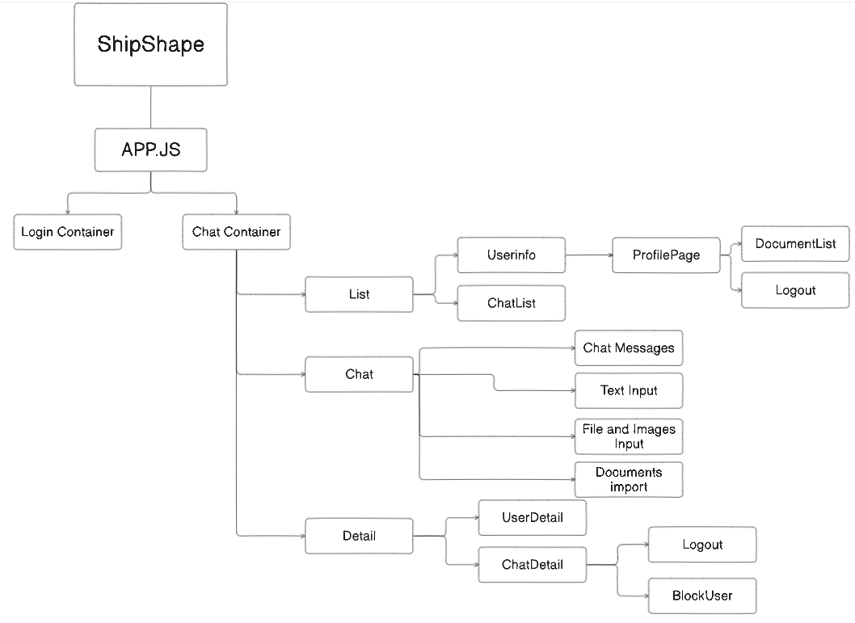

Image 3.1 – Shematic web application structure
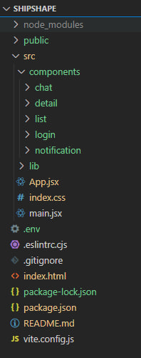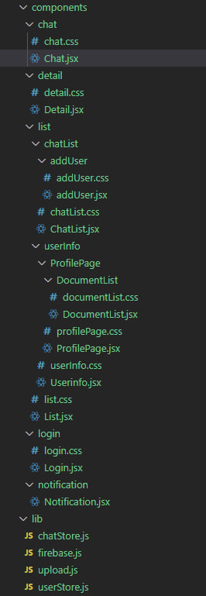
Image 3.2 – Web application structure Image 3.3 – Web application structure(detailed)

  - Designing the database structure

Designing the database structure is a pivotal aspect of developing our web application aimed at facilitating effective interaction between cruise companies and maritime professionals. Leveraging Firestore database as our backend solution, we need to tailor our database design to accommodate the specific requirements of our project.
In Firestore, data is organized into collections, each containing a set of documents. Our database structure will revolve around defining collections that represent essential entities within our application, such as Users, Companies, Professionals, Job Listings, Applications, and Messages.
For each entity, we'll carefully define the document schema, outlining the fields and their data types to accurately capture the relevant information. Given Firestore's flexible schema, we can adapt our structure to accommodate various attributes and ensure compatibility with our application's functionalities.
To model the relationships between entities, we'll utilize Firestore's nested data structure, embedding related data within documents where appropriate. This approach allows us to represent complex relationships efficiently and optimize data retrieval operations.
Considering scalability and performance requirements, we'll devise an indexing strategy to facilitate efficient querying and sorting of data. By defining composite indexes for common query patterns, we can ensure optimal database performance as our application scales.
Security is paramount, and we'll implement robust security rules to govern access to data based on user roles and permissions. By enforcing strict access controls, we'll protect sensitive information and prevent unauthorized access to critical data.
Maintaining data consistency and integrity is essential, and we'll employ transactional operations and batch writes to ensure atomicity and reliability of database transactions. Handling concurrency and race conditions effectively will help prevent data anomalies and maintain data reliability [6].
By meticulously designing the database structure tailored to our application's needs and Firestore's capabilities, we lay the groundwork for a robust and scalable web application that facilitates seamless interaction between cruise companies and maritime professionals.
The image 3.4 provides a visual overview of a database structure of ShipShape web-application.
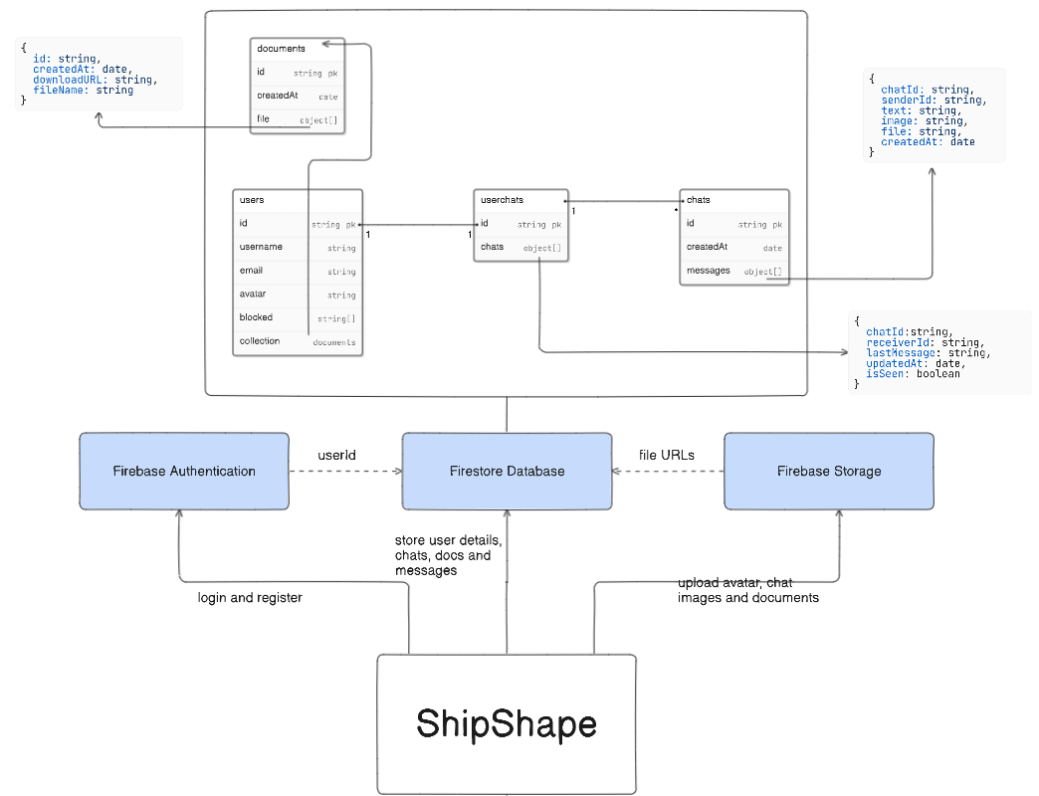

Image 3.4 – Database structure

3.3 Interface development

The interface of ShipShape Application was developed using Visual Studio Code.
Visual Studio Code is a widely-used source-code editor developed by Microsoft. While it's renowned for its exceptional support for various programming languages and frameworks, it's also an excellent choice for building online stores and web applications. Here are some standout features and capabilities of Visual Studio Code that make it an indispensable tool for crafting an online store:
- Versatile Workspace: Visual Studio Code offers a flexible workspace environment, allowing developers to seamlessly switch between different projects and folders. This versatility enables developers to manage multiple aspects of their online store, such as frontend code, backend logic, and configuration files, within a single editor window.
- Rich Language Support: Visual Studio Code supports an extensive array of programming languages and technologies, including JavaScript, TypeScript, HTML, CSS, and more. This broad language support empowers developers to work with diverse tech stacks and frameworks when building various components of their online store.
- Intuitive Code Editing: With its intuitive code editor, Visual Studio Code provides features like syntax highlighting, intelligent code completion, and built-in Git integration. These tools enhance productivity and code quality by assisting developers in writing, reviewing, and managing their codebase effectively.
- Extensions Marketplace: Visual Studio Code boasts a vast ecosystem of extensions available through its marketplace. Developers can augment their editor with extensions tailored to their specific needs, such as frontend frameworks (e.g., React, Vue.js), code linters, debuggers, and deployment tools, to streamline the development process for their online store.
- Debugging Capabilities: Visual Studio Code offers robust debugging capabilities for frontend and backend code, enabling developers to identify and resolve issues efficiently. It supports debugging in various environments, including browsers and server-side platforms, with features like breakpoints, watch variables, and interactive debugging consoles.
- Integrated Terminal: Visual Studio Code features an integrated terminal that allows developers to execute commands, run scripts, and interact with their development environment directly from the editor. This seamless integration simplifies tasks like running build scripts, managing dependencies, and executing version control commands for the online store project.
- Version Control Integration: Visual Studio Code seamlessly integrates with version control systems like Git, providing developers with powerful tools for managing their codebase and collaborating with teammates. It offers features such as visual diffing, branch management, and commit history navigation, enhancing the efficiency of code collaboration and project management.
- Extensive Customization: Visual Studio Code can be extensively customized to suit individual preferences and project requirements. Developers can personalize their editor experience by configuring settings, keybindings, themes, and UI layouts to optimize productivity and comfort while working on their online store project.
Visual Studio Code stands out as a versatile and powerful tool for developing online stores and web applications. Its broad language support, intuitive editing features, rich extension ecosystem, and seamless integration with development workflows make it an invaluable asset for developers seeking to create robust and scalable e-commerce solutions.
The image 3.5 shows the login and registration page, the fields that the user must fill in are shown here.

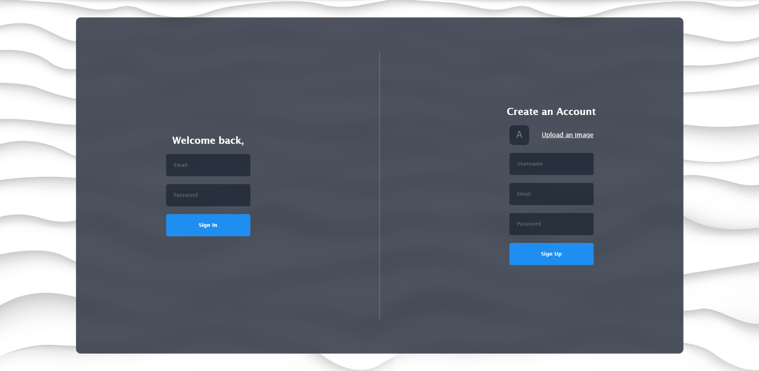
Image 3.5 – Registration and entry page

The image 3.6 shows the main page, which functions as a central hub for both seafarers and crewing agencies. This page offers streamlined access to key functionalities and prominently displays essential information. User details, including an avatar and username, are visible. A Profile Page link is located in the upper right corner. Additionally, there is a search bar for locating existing chats with other users and an "Add User" button on the right side for initiating new chats with new users. Below the search bar, a list of existing conversations is displayed.

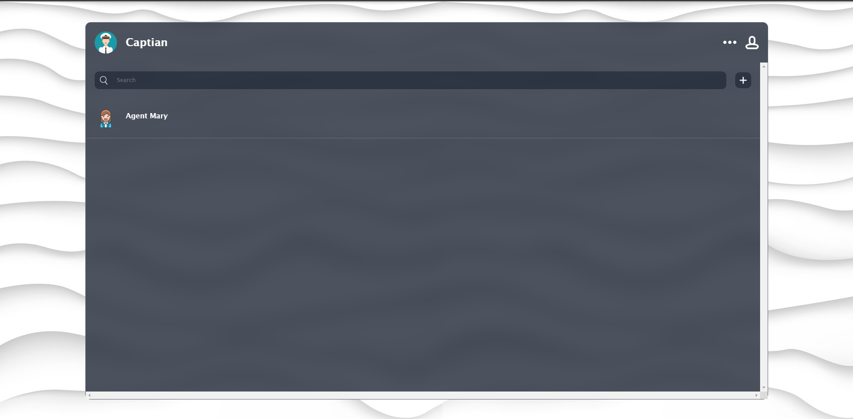
Image 3.6 – Main page

The image 3.7 illustrates the Add User page that containes a search bar for finding users by their usernames and a list of located users with the option to add them for chating.

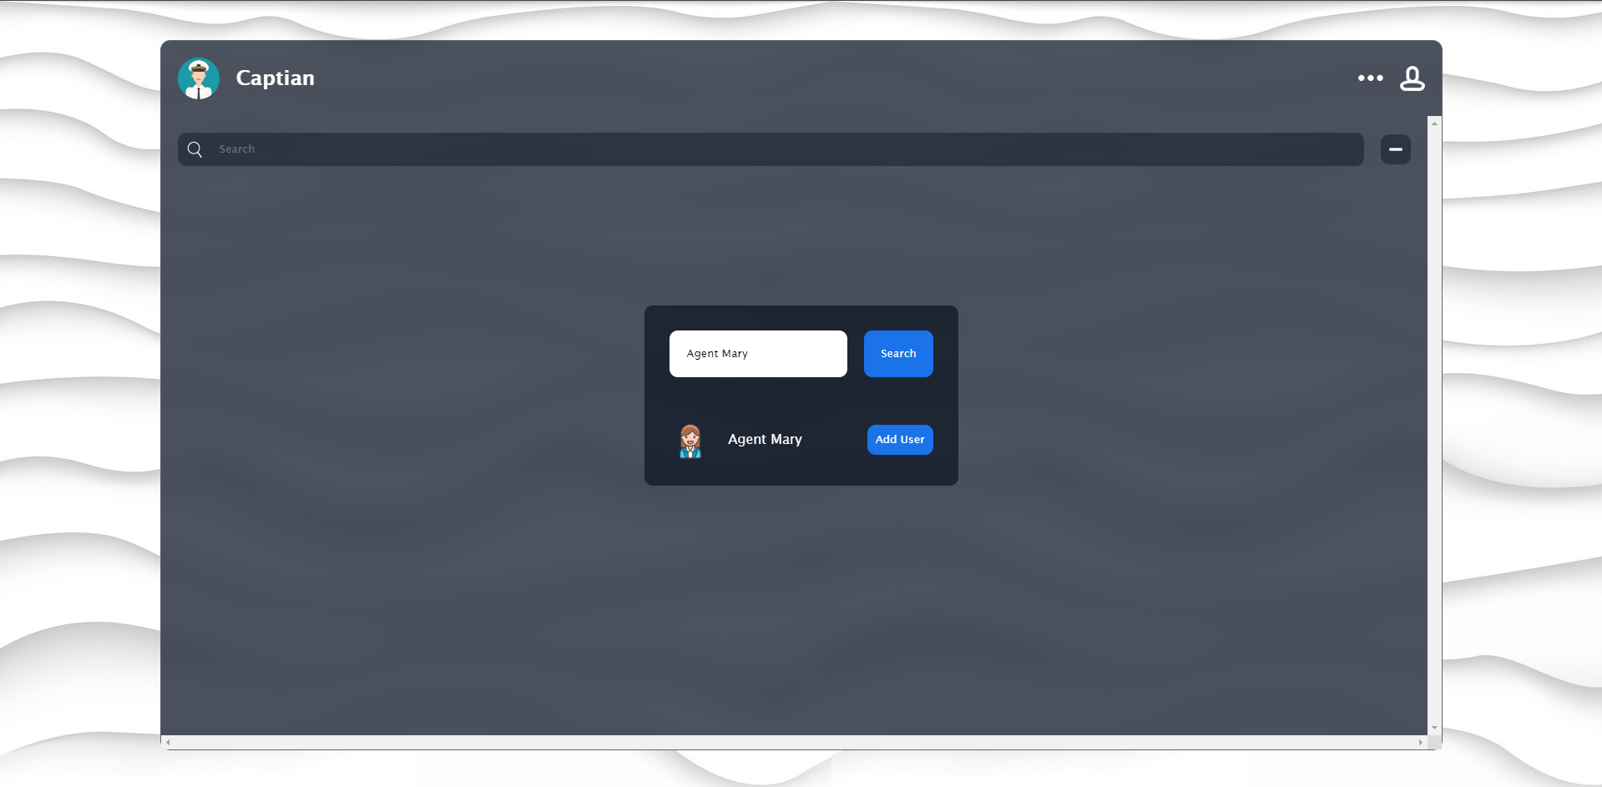
Image 3.7 – Add User page

The image 3.8 depicts the Chat page, which incorporates elements from the main page on the left side, such as user information, the Profile Page button, search bar, Add User button, and list of chats. The central section features the Chat component, which includes information about the interlocutor, a message window, a button for attaching files and images, a special button for attaching all documents from the Profile with a single click, and fields for text and image input. On the right side, the Detail component displays additional interlocutor information, along with buttons for blocking the user and logging out.

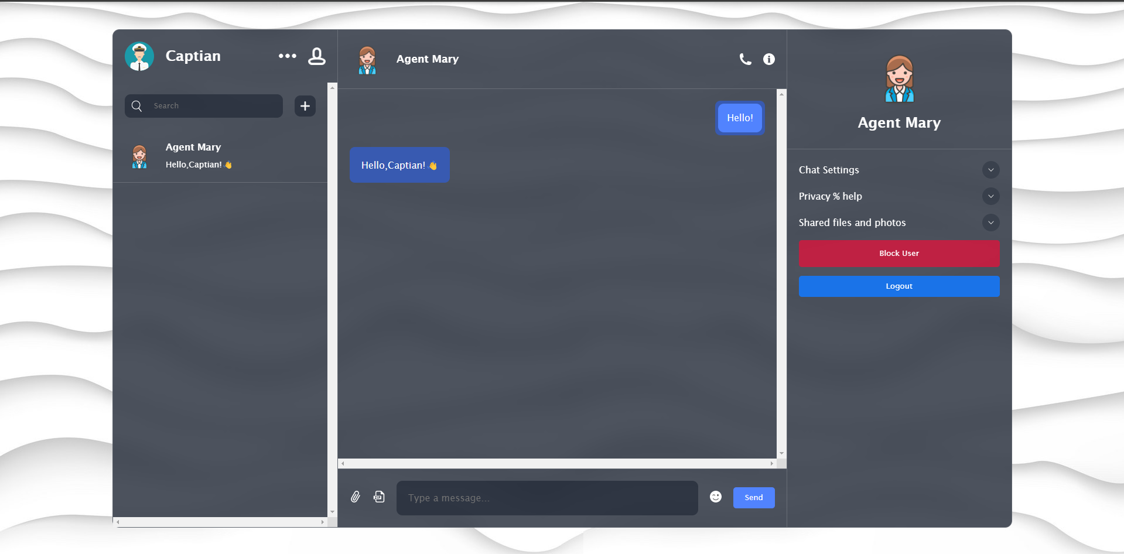
Image 3.8 – Chat page

The image 3.9 illustrates the Profile page, which displays user information including an avatar and username, along with a Document List component that can be expanded by clicking on it. Additionally, Edit and Logout buttons.

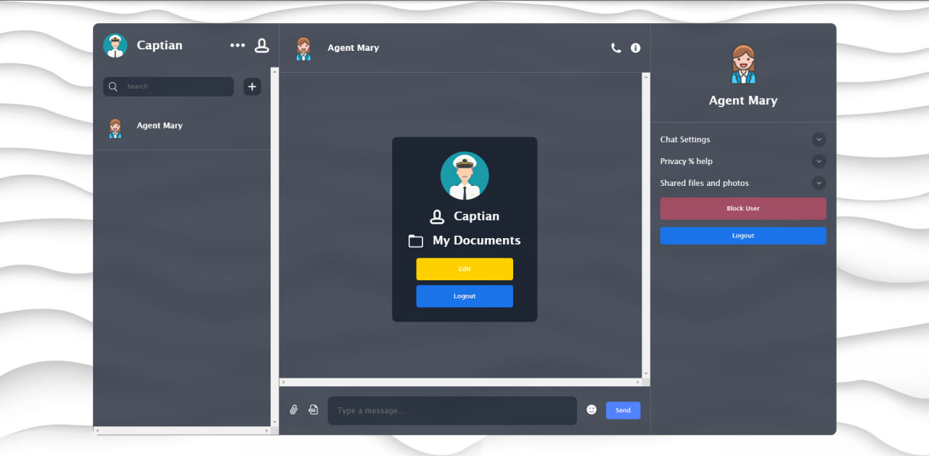
Image 3.9 – Profile Page

The image 3.10 also shows the Profile Page, but with the Documents List component expanded. This expanded view includes a file input field, an upload files button, and a list of documents.

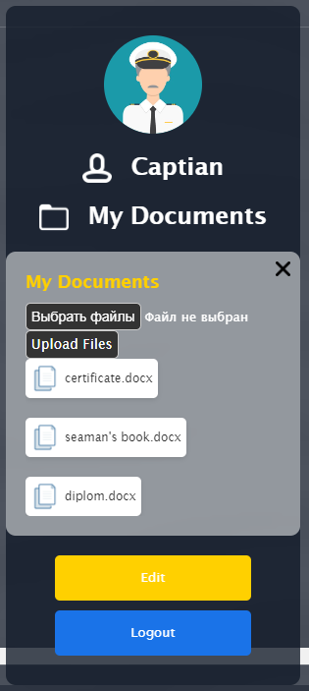
Image 3.9 – Profile Page (with expanded Documents list)

CONCLUSIONS AND RECOMMENDATIONS

In the course of this qualification work, various services for interaction between crewing companies and maritime professionals were reviewed and investigated. After analysing similar services, their main drawbacks were identified, such as the lack of a user-friendly interface for communication between users, limited document management capabilities, and problems with data security. Based on the analysis of the subject area of development, the main tasks and goal of developing a web application for effective interaction between crewing companies and maritime specialists were formulated.
To achieve this goal, modern technologies were used to ensure the convenience and functionality of the service. Various technological tools and methods were carefully considered when developing the application. The popular Firebase platform was used as the basis, which allowed us to quickly deploy the service and provide convenient management of the basic functions of the site. Firestore was used to store and manage user data, as well as to integrate modules to improve the user experience.
During the project execution, various technologies were utilized to ensure data integrity and security. To optimize the productivity of the web application, Vite was employed, providing rapid execution and quick response to changes. Specifically, an email-based authentication and authorization method was implemented to safeguard user data, along with encryption of data both at rest and in transit.
As a result of the work, a prototype web application was developed, successfully addressing the defined tasks and serving as a foundation for further service development and enhancement. Future steps include performance optimization, functionality expansion, and real-user testing to identify and rectify potential shortcomings.

LIST OF SOURCES OF REFERENCES

- Офіційна документація Firebase [Електронний ресурс] – Режим доступу: https://firebase.google.com/docs
- Застосування JavaScript для веб-розробки / Д. Флэнаган; пер. з англ. – Київ: Діалектика, 2021. – 1024с.
- Документація Node.js [Електронний ресурс] – Режим доступу: https://nodejs.org/en/docs/
- Документація Vite [Електронний ресурс] – Режим доступу: https://vitejs.dev/guide/
- Документація по Zustand [Електронний ресурс] – Режим доступу: https://zustand-demo.pmnd.rs/docs/getting-started
- Фрост Р. Проектування та розробка бази даних / Р. Фрост, Д. Дей, К. Ван Слайк; пер. з англ. А.Ю. Кухаренко. : НТ Пресс, 2007. – 65с.
- Arnold P.O.S. Vermeeren. " Design-inclusive UX research: design as a part of doing user experience research.", 2015, 21-37 с.
- Фаулер М. Рефакторинг. Покращення існуючого коду.: Діалектика, 2020 – 448 с.
- Документація React [Електронний ресурс] – Режим доступу: https://reactjs.org/docs/getting-started.html

APPENDIX A
List of copies of demonstration material
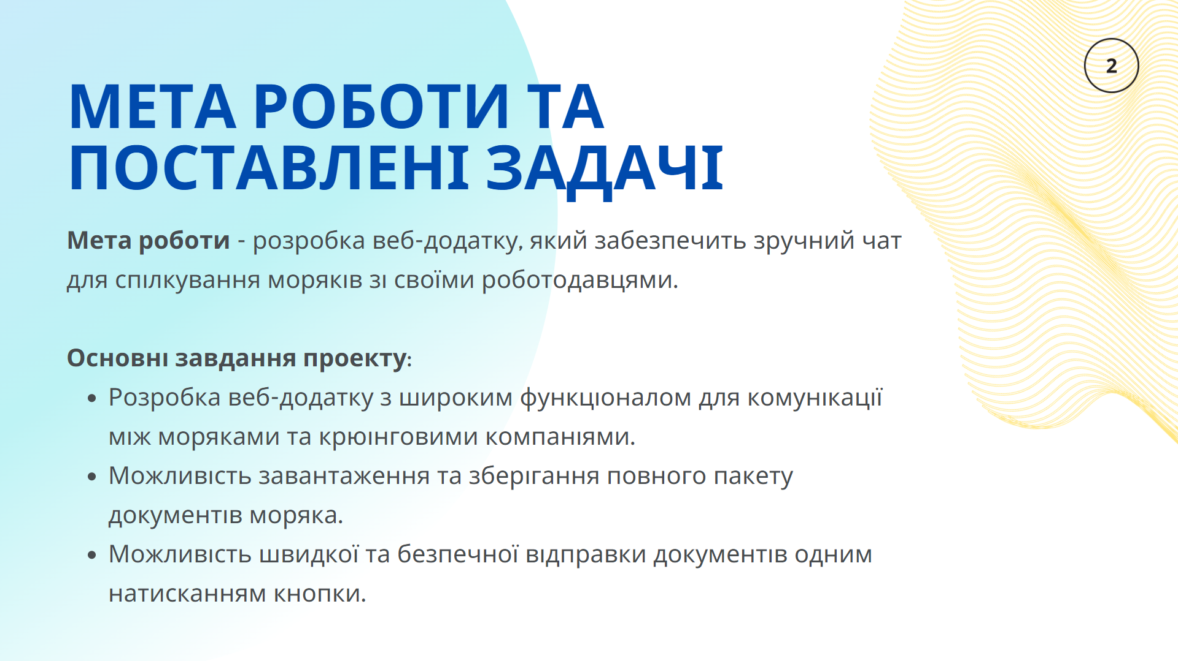
Image 1 – Slide “Мета роботи та поставлені задачі”
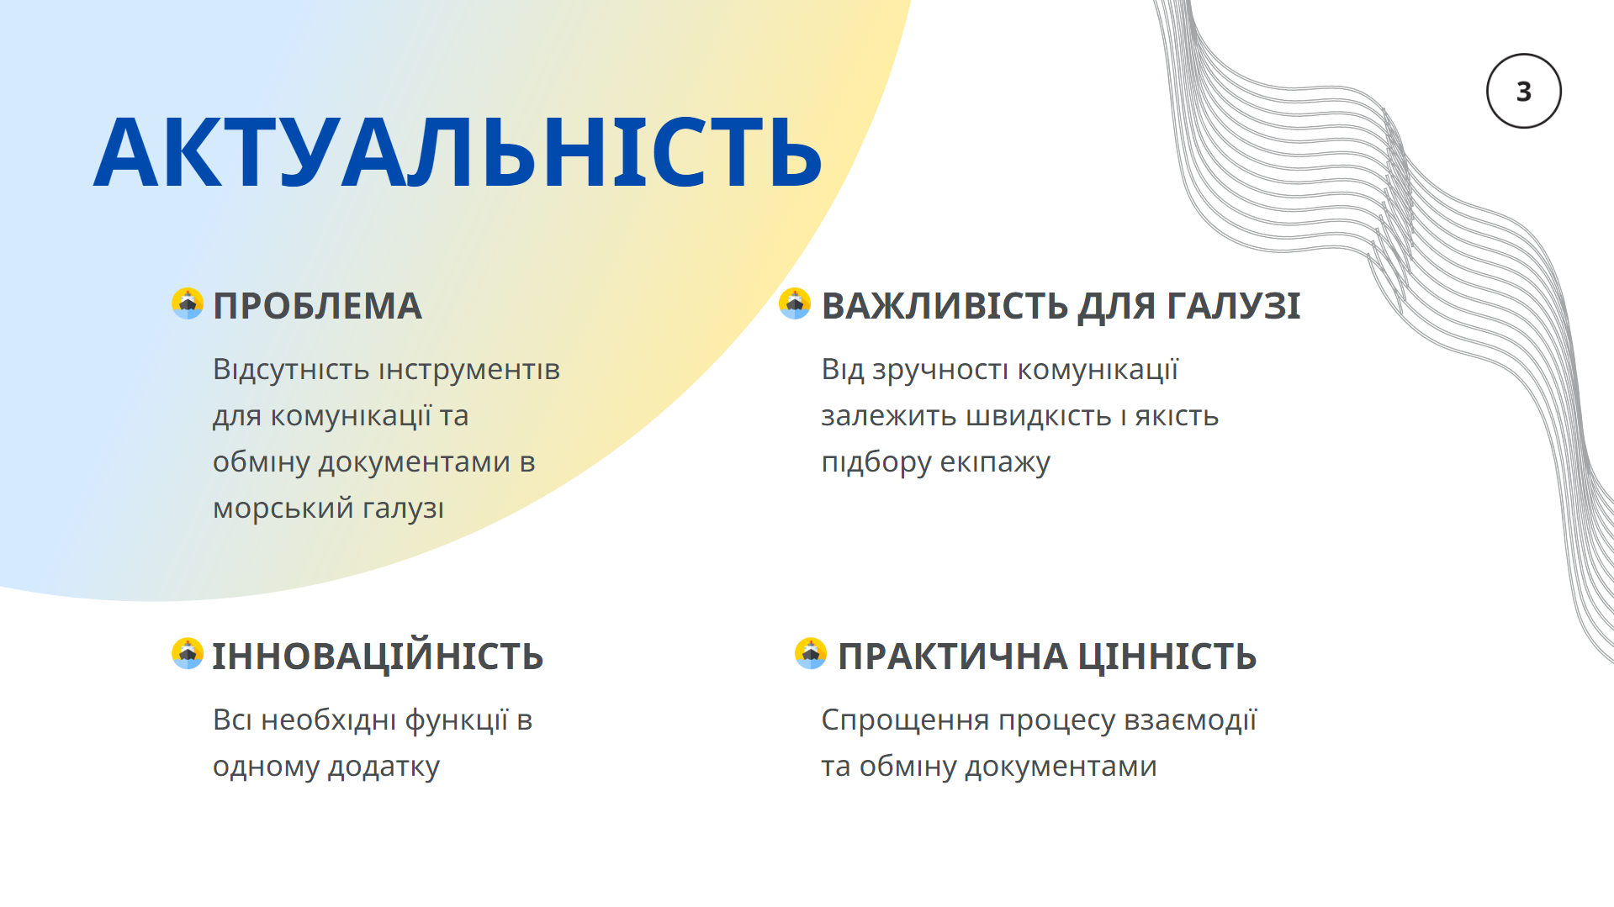
Image 2 – Slide “Актуальність роботи”
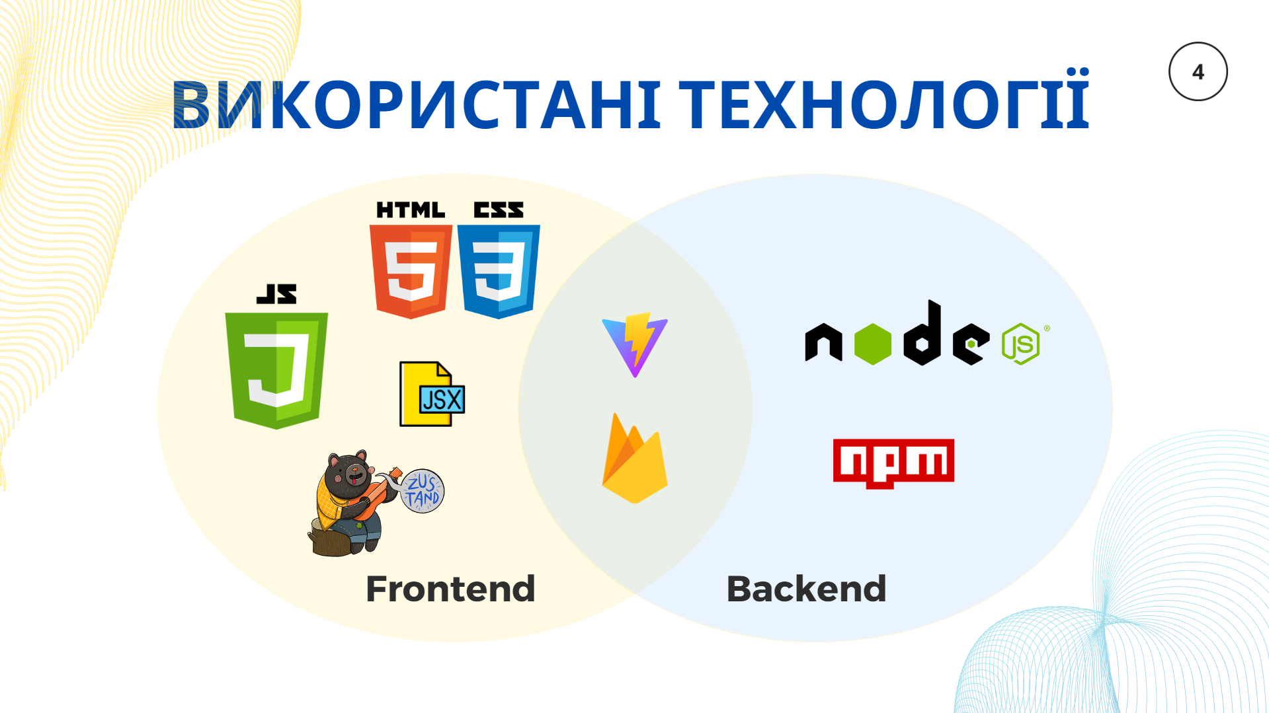
Image 3 – Slide “Використані технології”
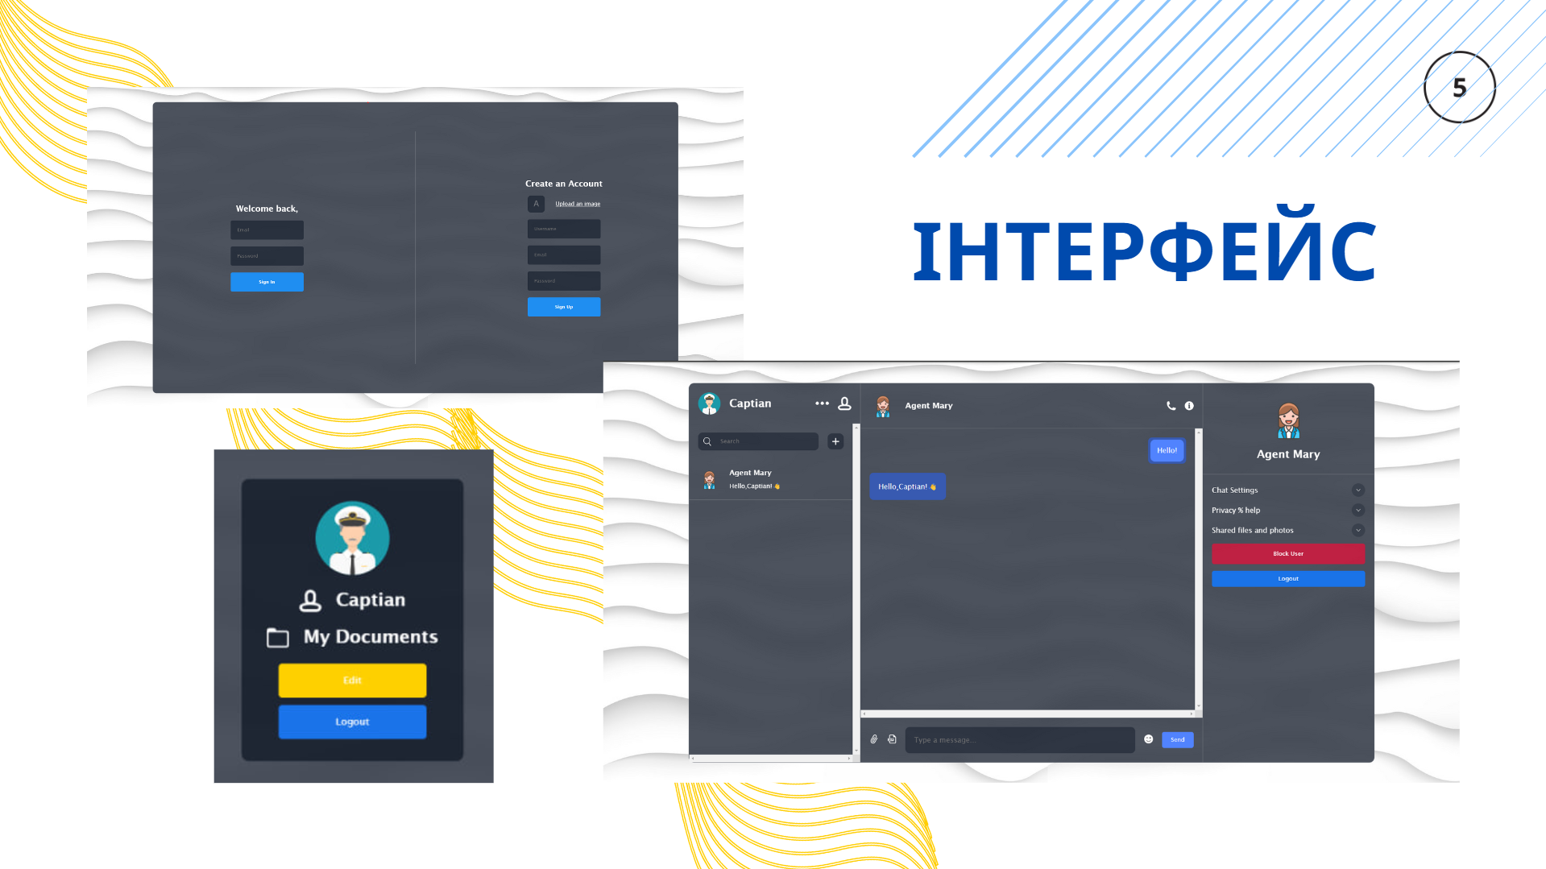
Image 4 – Slide “Інтерфейс додатку”
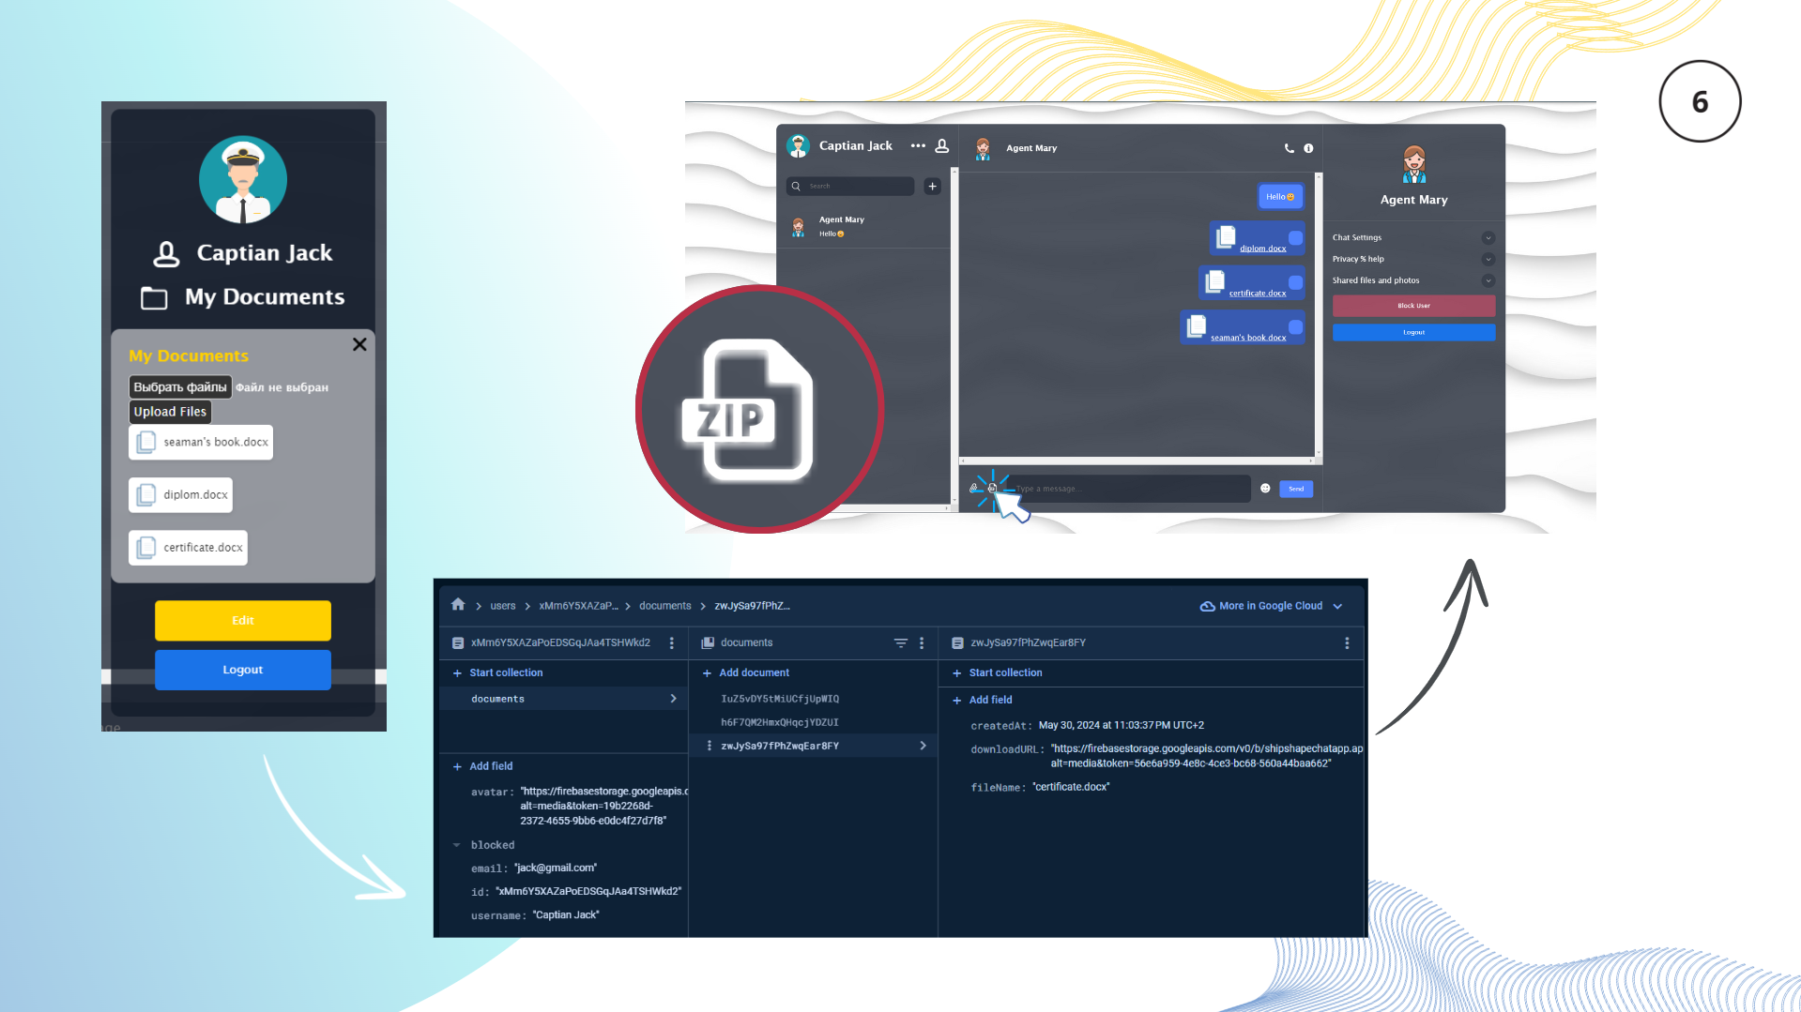
Image 5 – Slide “Функція відправки пакету документів”

User interface
Image 6 – Registration and entry page

Image 7 – Main page
Image 8 – Add User page

Image 9 – Chat page

Image 10 – Profile Page

Image 11 – Profile Page (with expanded Documents list)

APPENDIX В
Listings of software system modules
Listing C.1 - index.html
<!DOCTYPE html>
<html lang="en">
<head>
<meta charset="UTF-8" />
<link rel="icon" type="image/svg+xml" href="/favicon.png" />
<meta name="viewport" content="width=device-width, initial-scale=1.0" />
<title>ShipShape</title>
</head>
<body>
<div id="root"></div>
<script type="module" src="/src/main.jsx"></script>
</body>
</html>

Listing C.2 - vite.config.js
import { defineConfig } from 'vite'
import react from '@vitejs/plugin-react'

// https://vitejs.dev/config/
export default defineConfig({
plugins: [react()],
})

Listing C.3 - App.js
import Login from "./components/login/Login";
import Chat from "./components/chat/Chat";
import Detail from "./components/detail/Detail";
import List from "./components/list/List";
import Notification from "./components/notification/Notification";
import { useEffect } from "react";
import { onAuthStateChanged } from "@firebase/auth";
import { auth } from "./lib/firebase";
import { useUserStore } from "./lib/userStore";
import { useChatStore } from "./lib/chatStore";

const App = () => {

const { currentUser, isLoading, fetchUserInfo } = useUserStore();
const { chatId} = useChatStore();

useEffect(() => {
const unSub = onAuthStateChanged(auth, (user) => {
fetchUserInfo(user?.uid);
})

return () => {
unSub();
}
}, [fetchUserInfo]);

console.log(currentUser);

if(isLoading) return <div className="loading">Loading...</div>

return (
<div className='container'>
{
currentUser ? (
<>
<List />
{chatId && <Chat />}
{chatId && <Detail />}
</>
) : (
<Login />
)}
<Notification/>
</div>
)
}

export default App;

Listing C.4 - main.jsx
import React from 'react'
import ReactDOM from 'react-dom/client'
import App from './App.jsx'
import './index.css'

ReactDOM.createRoot(document.getElementById('root')).render(
<React.StrictMode>
<App />
</React.StrictMode>,
)

Listing C.5 - index.css
* {
margin: 0;
padding: 0;
box-sizing: border-box;
font-family: "Lucida Sans", "Lucida Sans Regular", "Lucida Grande",
"Lucida Sans Unicode", Geneva, Verdana, sans-serif;
}

body {
background-image: url("/bg.jpg");
display: flex;
align-items: center;
justify-content: center;
height: 100vh;
color: white;
}

.container {
width: 80vw;
height: 90vh;
background-color: rgba(17, 25, 40, 0.75);
backdrop-filter: blur(19px) saturate(180%);
border-radius: 12px;
border: 1px solid rgba(255, 255, 255, 0.125);
display: flex;
}

.loading {
padding: 50px;
font-size: 36px;
border-radius: 10px;
background-color: rgba(17, 25, 40, 0.9);
}

Listing C.6 - Login.jsx
import { useState } from "react";
import "./login.css";
import { toast } from "react-toastify";
import {createUserWithEmailAndPassword, signInWithEmailAndPassword} from "firebase/auth"
import { auth, db } from "../../lib/firebase";
import { doc, setDoc } from "firebase/firestore";
import upload from "../../lib/upload";

const Login = () => {
const [avatar, setAvatar] = useState({
file: null,
url: ""
});

const [loading, setLoading] = useState(false);

const handleAvatar = e => {
if (e.target.files[0]) {
setAvatar({
file: e.target.files[0],
url: URL.createObjectURL(e.target.files[0])
})
}
}

const handleLogin = async (e) => {
e.preventDefault();
setLoading(true);

const formData = new FormData(e.target);
const {email, password } = Object.fromEntries(formData);

try {
await signInWithEmailAndPassword(auth, email, password);
} catch (err) {
console.log(err);
toast.error(err.message);
} finally {
setLoading(false);
}
}

const handleRegister = async (e) => {
e.preventDefault();
setLoading(true);
const formData = new FormData(e.target)

const { username, email, password } = Object.fromEntries(formData);

try {
const res = await createUserWithEmailAndPassword(auth, email, password);

const imgUrl = await upload(avatar.file)

await setDoc(doc(db, "users", res.user.uid), {
username,
email,
avatar:imgUrl,
id: res.user.uid,
blocked: [],
});

await setDoc(doc(db, "userchats", res.user.uid), {
chats:[]
});

toast.success("Account created! You can login now!");

} catch (err) {
console.log(err)
toast.error(err.message)
} finally {
setLoading(false);
}
}

return (
<div className='login'>
<div className="item">
<h2>Welcome back,</h2>
<form onSubmit={handleLogin}>
<input type="text" placeholder="Email" name="email" />
<input type="password" placeholder="Password" name="password" />
<button disabled={loading}>{loading ? "Loading" : "Sign In" }</button>
</form>
</div>
<div className="separator"></div>
<div className="item">
<h2>Create an Account</h2>
<form onSubmit={handleRegister}>
<label htmlFor="file">
<img src={avatar.url || "./avatar.png"} alt="" />
Upload an image</label>
<input type="file" id="file" style={{display:"none"}} onChange={handleAvatar}/>
<input type="text" placeholder="Username" name="username" />
<input type="text" placeholder="Email" name="email" />
<input type="password" placeholder="Password" name="password" />
<button disabled={loading}>{loading ? "Loading" : "Sign Up" }</button>
</form>
</div>
</div>
)
}

export default Login;

Listing C.7 - login.css
.login {
width: 100%;
height: 100%;
display: flex;
align-items: center;
gap: 100px;

.item {
flex: 1;
display: flex;
flex-direction: column;
align-items: center;
gap: 20px;

form {
display: flex;
flex-direction: column;
align-items: center;
justify-content: center;
gap: 20px;

input {
padding: 20px;
border: none;
outline: none;
background-color: rgba(17, 25, 40, 0.6);
color: white;
border-radius: 5px;
}

label {
width: 100%;
display: flex;
align-items: center;
justify-content: space-between;
cursor: pointer;
text-decoration: underline;

img {
width: 50px;
height: 50px;
border-radius: 10px;
object-fit: cover;
opacity: 0.6;
}
}

button {
width: 100%;
padding: 20px;
border: none;
background-color: #1f8ef1;
color: white;
border-radius: 5px;
cursor: pointer;
font-weight: 500;

&:disabled {
cursor: not-allowed;
background-color: #1f8ff19c;
}
}
}
}

.separator {
height: 80%;
width: 2px;
background-color: #dddddd35;
}
}

Listing C.8 - List.jsx
import ChatList from "./chatList/ChatList";
import "./list.css";
import Userinfo from "./userInfo/Userinfo";

const List = () => {
return (
<div className='list'>
<Userinfo />
<ChatList/>
</div>
)
}

export default List;

Listing C.9 - list.css
.list {
flex: 1;
display: flex;
flex-direction: column;
}

Listing C.10 - ChatList.jsx
import { useEffect, useState } from "react";
import "./chatList.css";
import AddUser from "./addUser/addUser";
import { useUserStore } from "../../../lib/userStore";
import { doc, getDoc, onSnapshot } from "firebase/firestore";
import { db } from "../../../lib/firebase";
import { useChatStore } from "../../../lib/chatStore";

const ChatList = () => {

const [chats, setChats] = useState([]);
const [addMode, setAddMode] = useState(false);
const [input, setInput] = useState("");

const { currentUser } = useUserStore();
const { chatId, changeChat } = useChatStore();

console.log(chatId);

useEffect(() => {
const unSub = onSnapshot(doc(db, "userchats", currentUser.id), async (res) => {
const items = res.data().chats;

const promises = items.map(async (item) => {
const userDocRef = doc(db, "users", item.receiverId);
const userDocSnap = await getDoc(userDocRef);

const user = userDocSnap.data();

return { ...item, user };
});

const chatData = await Promise.all(promises);

setChats(chatData.sort((a,b)=>b.updatedAt-a.updatedAt));
});

return () => {
unSub();
};
}, [currentUser.id]);

const handleSelect = async (chat) => {
changeChat(chat.chatId,chat.user)
}

const filteredChats = chats.filter(c =>
c.user.username.toLowerCase().includes(input.toLowerCase())
);

return (
<div className="chatList">
<div className="search">
<div className="searchBar">
<img src="./search.png" alt="" />
<input type="text" placeholder="Search" onChange={(e)=>setInput(e.target.value)}/>
</div>
<img src={addMode ? "./minus.png" : "./plus.png"} alt=""
className="add"
onClick={() => setAddMode((prev) => !prev)} />
</div>
{filteredChats.map((chat) => (
<div className="item" key={chat.chatId} onClick={()=>handleSelect(chat)}>
<img src={chat.user.blocked.includes(currentUser.id)
? "./avatar.png"
: chat.user.avatar || "./avatar.png"} alt="" />
<div className="texts">
<span>{chat.user.blocked.includes(currentUser.id)
? "User"
: chat.user.username}
</span>
<p>{chat.lastMessage}</p>
</div>
</div>
))}

{addMode && <AddUser />}
</div>
);
};

export default ChatList;

Listing C.11 - chatList.css
.chatList {
flex: 1;
overflow: scroll;

.search {
display: flex;
align-items: center;
gap: 20px;
padding: 20px;

.searchBar {
flex: 1;
background-color: rgba(17, 25, 40, 0.5);
display: flex;
align-items: center;
gap: 20px;
border-radius: 10px;
padding: 10px;

input {
background-color: transparent;
border: none;
outline: none;
color: white;
flex: 1;
}

img {
width: 20px;
height: 20px;
}
}

.add {
width: 36px;
height: 36px;
background-color: rgba(17, 25, 40, 0.5);
padding: 10px;
border-radius: 10px;
cursor: pointer;
}
}

.item {
display: flex;
align-items: center;
gap: 20px;
padding: 20px;
cursor: pointer;
border-bottom: 1px solid #dddddd35;

img {
width: 50px;
height: 50px;
border-radius: 50%;
object-fit: cover;
}

.texts {
display: flex;
flex-direction: column;
gap: 10px;

span {
font-weight: 500;
}

p {
font-size: 14px;
font-weight: 300;
}
}
}
}

Listing C.12 - AddUser.jsx
import "./addUser.css"
import { db } from "../../../../lib/firebase";
import {
arrayUnion,
collection,
doc,
getDoc,
getDocs,
query,
serverTimestamp,
setDoc,
updateDoc,
where,
} from "firebase/firestore";
import { useState } from "react";
import { useUserStore } from "../../../../lib/userStore"

const AddUser = () => {
const [user, setUser] = useState(null);

const { currentUser } = useUserStore();

const handleSearch = async (e) => {
e.preventDefault();
const formData = new FormData(e.target);
const username = formData.get("username");

try {
const userRef = collection(db, "users");

const q = query(userRef, where("username", "==", username));

const querySnapShot = await getDocs(q);

if (!querySnapShot.empty) {
setUser(querySnapShot.docs[0].data());
}
} catch (err) {
console.log(err);
}
};

const handleAdd = async () => {
const chatRef = collection(db, "chats");
const userChatsRef = collection(db, "userchats");

try {
const newChatRef = doc(chatRef);

await setDoc(newChatRef, {
createdAt: serverTimestamp(),
messages: [],
});

await updateDoc(doc(userChatsRef, user.id), {
chats: arrayUnion({
chatId: newChatRef.id,
lastMessage: "",
receiverId: currentUser.id,
updatedAt: Date.now(),
}),
});

await updateDoc(doc(userChatsRef, currentUser.id), {
chats: arrayUnion({
chatId: newChatRef.id,
lastMessage: "",
receiverId: user.id,
updatedAt: Date.now(),
}),
});
} catch (err) {
console.log(err);
}
};

return (
<div className="addUser">
<form onSubmit={handleSearch}>
<input type="text" placeholder="Username" name="username" />
<button>Search</button>
</form>
{user && (
<div className="user">
<div className="detail">
<img src={user.avatar || "./avatar.png"} alt="" />
<span>{user.username}</span>
</div>
<button onClick={handleAdd}>Add User</button>
</div>
)}
</div>
);
};

export default AddUser;

Listing C.13 - addUser.css
.addUser {
width: max-content;
height: max-content;
padding: 30px;
background-color: rgba(17, 25, 40, 0.781);
border-radius: 10px;
position: absolute;
top: 0;
bottom: 0;
left: 0;
right: 0;
margin: auto;

form {
display: flex;
gap: 20px;

input {
padding: 20px;
border-radius: 10px;
border: none;
outline: none;
}

button {
padding: 20px;
border-radius: 10px;
background-color: #1a73e8;
color: white;
border: none;
cursor: pointer;
}
}

.user {
margin-top: 50px;
display: flex;
align-items: center;
justify-content: space-between;

.detail {
display: flex;
align-items: center;
gap: 20px;

img {
width: 50px;
height: 50px;
border-radius: 50%;
object-fit: cover;
}
}

button {
padding: 10px;
border-radius: 10px;
background-color: #1a73e8;
color: white;
border: none;
cursor: pointer;
}
}
}

Listing C.14 - UserInfo.jsx
const Userinfo = () => {
const { currentUser } = useUserStore();
const [showProfilePage, setShowProfilePage] = useState(false); // State to control the visibility of ProfilePage

const toggleProfilePage = () => {
setShowProfilePage(!showProfilePage);
};

return (
<div className='userInfo'>
<div className="user">
<img src={currentUser.avatar || "./avatar.png"} alt="" />
<h2>{currentUser.username}</h2>
</div>
<div className="icons">
<img src="./more.png" alt="" />
<img src="./profile.png" alt="" onClick={toggleProfilePage}/> {/* Toggle ProfilePage visibility on click */}
</div>
{showProfilePage && <ProfilePage />}
</div>
);
};

export default Userinfo;

Listing C.15 - userInfo.css
.userInfo{
padding: 20px;
display: flex;
align-items: center;
justify-content: space-between;

.user {
display: flex;
align-items: center;
gap: 20px;

img {
width: 50px;
height: 50px;
border-radius: 50%;
object-fit: cover;
}
}

.icons {
display: flex;
gap: 20px;

img {
width: 30px;
height: 30px;
cursor: pointer;
}
}}

Listing C.16 - ProfilePage.jsx
const ProfilePage = () => {
const { currentUser } = useUserStore();
const [showDocumentList, setShowDocumentList] = useState(false);

const toggleDocumentList = () => {
setShowDocumentList(!showDocumentList);
};

return (
<div className="profilePage">
<div className="userProfile">
<img src={currentUser.avatar || "./avatar.png"} alt="User Avatar" className="avatar" />
<div className="namerow">
<img src="./profile.png" alt="" />
<div><h2>{currentUser.username}</h2></div>
</div>
</div>
<div className="documentContainer">
<img src="./folder.png" alt="" />
<div className="documentLink">
<a href="#" onClick={toggleDocumentList}><h2>My Documents</h2></a>
</div>
</div>
{showDocumentList && <DocumentList onClose={toggleDocumentList} />}
<div className="profileActions">
<button className="edit">Edit</button>
<button className="logout">Logout</button>
</div>
</div>
);
};
export default ProfilePage;

Listing C.17 - profilePage.css
.profilePage {
width: 300px;
height: max-content;
padding: 30px;
background-color: rgba(17, 25, 40, 0.781);
border-radius: 10px;
position: absolute;
top: 0;
bottom: 0;
left: 0;
right: 0;
margin: auto;
display: flex;
flex-direction: column;
align-items: center;
gap: 20px;
justify-content: center;

.userProfile {
display: flex;
flex-direction: column;
align-items: center;
gap: 20px;

img {
width: 100px;
height: 100px;
border-radius: 50%;
object-fit: cover;
}

}

.namerow, .documentContainer{
display: flex;
flex-direction: row;
gap: 20px;

a{
color: rgb(255, 255, 255);
text-decoration: none;
}

a:hover{
color: #1a73e8;
}

img{
width: 30px;
height: 30px;
border-radius: 0%;
object-fit: cover;
}

.documentLink {
position: relative;
/* Ensure the close button is positioned relative to this container */
}

}

.profileActions {
display: flex;
flex-direction: column;
gap: 10px;

button {
width: 200px;
padding: 15px;
background-color: rgb(255, 208, 0);
color: white;
border: none;
border-radius: 5px;
cursor: pointer;

&:hover {
background-color:rgba(216, 186, 50, 0.553);
}

&.logout {
padding: 15px;
background-color: #1a73e8;

&:hover{
background-color: #1a73e89c;
}
}
}
}}

Listing C.18 - DocumentList.jsx
const DocumentList = ({ onClose }) => {
const { currentUser } = useUserStore();
const [files, setFiles] = useState([]);

useEffect(() => {
const getDocuments = async () => {
if (!currentUser) return;

try {
const q = query(collection(db, `users/${currentUser.id}/documents`));
const querySnapshot = await getDocs(q);
const documents = [];
querySnapshot.forEach((doc) => {
documents.push(doc.data());
});
setFiles(documents);
} catch (error) {
console.error('Error getting documents:', error);
}
};

getDocuments();
}, [currentUser.id]);

const handleFileChange = (e) => {
const fileList = e.target.files;
const newFiles = [];

for (let i = 0; i < fileList.length; i++) {
const file = fileList.item(i);
newFiles.push(file);
}

setFiles(newFiles);
};

const uploadFiles = async () => {
const storageRef = ref(storage, `docs/${currentUser.id}`);

files.forEach(async (file) => {
try {
const downloadURL = await upload(file);
console.log("File uploaded successfully:", downloadURL);
saveFileToProfile(currentUser.id, file.name, downloadURL);
} catch (error) {
console.error("Error uploading file:", error);
}
});
setFiles([]);
};

const saveFileToProfile = async (userId, fileName, downloadURL) => {
try {
const docRef = await addDoc(collection(db, `users/${userId}/documents`), {
fileName,
downloadURL,
createdAt: new Date()
});
console.log("Document saved to user profile:", docRef.id);
} catch (error) {
console.error("Error saving document to user profile:", error);
}
};

const openFile = (file) => {
window.open(file.downloadURL, '_blank');
};

return (
<div className="documentList">
<img
src="./close.png"
alt="Close"
className="closeButton"
onClick={onClose}
/>
<h2>My Documents</h2>
<div className="documentInput">
<input type="file" id="fileInput" multiple onChange={handleFileChange} />
<button onClick={uploadFiles}>Upload Files</button>
</div>
<div className="documentContainer">
{files.map((file, index) => (
<div className="documentItem" key={index} onClick={() => openFile(file)}>
<img src="./file.png" alt="File Icon" />
<span>{file.fileName}</span>
</div>
))}
</div>
</div>
);
};

export default DocumentList;

Listing C.19 - documentList.css
.documentList {
width: 300px;
padding: 20px;
background-color:rgba(255, 255, 255, 0.521);
border-radius: 10px;
position: relative;

}

.documentList img.closeButton {
position: absolute;
top: 10px;
right: 10px;
width: 15px !important;
height: 15px !important;
cursor: pointer;
}

.documentList h2 {
margin-bottom: 10px;
font-size: 18px;
color: rgb(255, 208, 0);
}

.documentContainer {
display: flex;
flex-direction: column;
flex-wrap: wrap;
gap: 10px;
overflow-y: auto;
max-height: 300px;
}

.documentItem {
display: flex;
flex-direction: row;
align-items: center;
gap: 5px;
padding: 5px;
background-color: #fff;
border-radius: 5px;
box-shadow: 0px 2px 5px rgba(0, 0, 0, 0.1);
}

.documentItem img {
width: 30px;
height: 30px;
}

.documentItem a {
text-decoration: none;
color: #333;
font-size: 14px;
}

.documentItem span {
font-size: 12px;
color: #333;
}

.documentInput input[type="file"]::-webkit-file-upload-button {
background-color: #333;
color: #fff;
padding: 5px 5px;
border: 1px solid #ccc;
border-radius: 5px;
cursor: pointer;
font-size: 14px;
transition: background-color 0.3s ease;
}

.documentInput button{
background-color: #333;
color: #fff;
padding: 5px 5px;
border: 1px solid #ccc;
border-radius: 5px;
cursor: pointer;
font-size: 14px;
transition: background-color 0.3s ease;
}

Listing C.20 - Chat.jsx
const Chat = () => {
const [chat, setChat] = useState([]);
const [open, setOpen] = useState(false);
const [text, setText] = useState("");
const [files, setFiles] = useState([]);
const [filesToSend, setFilesToSend] = useState([]);
const maxFiles = 10;

const { currentUser } = useUserStore();
const { chatId, user, isCurrentUserBlocked, isReceiverBlocked } = useChatStore();

const endRef = useRef(null);

useEffect(() => {
endRef.current?.scrollIntoView({ behavior: "smooth" });
}, []);

useEffect(() => {
const unSub = onSnapshot(doc(db, "chats", chatId), (res) => {
setChat(res.data()?.messages || []);
})

return () => {
unSub();
};
}, [chatId]);

const handleEmoji = e => {
setText(prev => prev + e.emoji);
setOpen(false);
};

const handleFile = e => {
const selectedFiles = e.target.files;
if (selectedFiles.length > 0) {
const newFiles = Array.from(selectedFiles).slice(0, maxFiles);
setFiles(prevFiles => [...prevFiles, ...newFiles]);

// Добавляем выбранные файлы в состояние filesToSend
setFilesToSend(prevFiles => [...prevFiles, ...newFiles]);
}
};

const handleSend = async () => {
try {
if (text.trim() !== "") {
await updateDoc(doc(db, "chats", chatId), {
messages: arrayUnion({
senderId: currentUser.id,
text,
createdAt: new Date(),
}),
});
}

if (filesToSend.length > 0) {
for (const file of filesToSend) {
const fileUrl = await upload(file);
await updateDoc(doc(db, "chats", chatId), {
messages: arrayUnion({
senderId: currentUser.id,
file: { url: fileUrl, name: file.name },
createdAt: new Date(),
}),
});
}
}

const userIDs = [currentUser.id, user.id];

userIDs.forEach(async (id) => {
const userChatsRef = doc(db, "userchats", id);
const userChatsSnapshot = await getDoc(userChatsRef);

if (userChatsSnapshot.exists()) {
const userChatsData = userChatsSnapshot.data();

const chatIndex = userChatsData.chats.findIndex((c) => c.chatId === chatId);

if (chatIndex !== -1) {
userChatsData.chats[chatIndex].lastMessage =
text || (filesToSend.length > 0 ? filesToSend[filesToSend.length - 1].name : "");
userChatsData.chats[chatIndex].isSeen = id === currentUser.id ? true : false;
userChatsData.chats[chatIndex].updatedAt = Date.now();

await updateDoc(userChatsRef, {
chats: userChatsData.chats,
});
}
}
});

setText("");
setFiles([]);
setFilesToSend([]);
} catch (err) {
console.log(err);
}
};

const uploadFile = async (file) => {
const fileRef = ref(storage, `files/${file.name}`);
return uploadBytesResumable(fileRef, await fetch(file.url).then((response) => response.blob()));
};

const handleAttachAll = async () => {
try {
const userDocumentsRef = collection(db, `users/${currentUser.id}/documents`);
const userDocumentsSnapshot = await getDocs(userDocumentsRef);

const filesToSend = [];
for (const doc of userDocumentsSnapshot.docs) {
const documentData = doc.data();
const fileUrl = documentData.fileUrl;
const fileName = documentData.fileName;
const existingFileIndex = chat.findIndex(
(message) => message.file && message.file.url === fileUrl
);

if (existingFileIndex === -1 && !isCurrentUserBlocked) {
filesToSend.push({ url: fileUrl, name: fileName });
}
}

if (filesToSend.length === 0) {
console.log("No new files to send.");
return;
}

for (const file of filesToSend) {
const fileRef = ref(storage, `files/${file.name}`);
const uploadTask = uploadBytesResumable(fileRef, await fetch(file.url).then((response) => response.blob()));

uploadTask.on('state_changed',
null,
error => console.error(error),
async () => {
const downloadURL = await getDownloadURL(uploadTask.snapshot.ref);

await updateDoc(doc(db, "chats", chatId), {
messages: arrayUnion({
senderId: currentUser.id,
file: {
url: downloadURL,
name: file.name,
type: file.type || "application/octet-stream",
},
createdAt: new Date(),
}),
});
}
);
}

// Update user chats with last message and seen status
// ... (code remains the same as before)

console.log("Documents sent to chat successfully");
} catch (error) {
console.error("Error sending documents to chat:", error);
}
};

return (
<div className='chat'>
<div className="top">
<div className="user">
<img src={user?.avatar || "./avatar.png"} alt="" />
<div className="texts">
<span>{user?.username}</span>
</div>
</div>
<div className="icons">
<img src="./phone.png" alt="" />
<img src="./info.png" alt="" />
</div>
</div>

<div className="center">
{chat.map((message, index) => (
<div className={message.senderId === currentUser?.id ? "message own" : "message"} key={index}>
<div className="texts">
{message.img && <img src={message.img} alt="" />}
{message.file && !message.img && (
<div>
<img src="./file.png" alt="" className="fileimg"/>
<a href={message.file.url} target="_blank" rel="noopener noreferrer" download={message.file.name}>{message.file.name}</a>
</div>
)}
<p>{message.text}</p>
</div>
</div>
))}
<div ref={endRef}></div>
</div>

<div className="bottom">
<div className="icons">
<label htmlFor="file"><img src="./attach.png" alt="" /></label>
<input type="file" id="file" style={{ display: "none" }} onChange={handleFile} multiple />
<img src="./attach-all.png" alt="" onClick={handleAttachAll} disabled={isCurrentUserBlocked || isReceiverBlocked}/>
</div>
<input
type="text"
placeholder={(isCurrentUserBlocked || isReceiverBlocked)
? "You can't send a message"
: "Type a message..."
}
value={text}
onChange={(e) => setText(e.target.value)}
disabled={isCurrentUserBlocked || isReceiverBlocked}
/>
<div className="emoji">
<img src="./emoji.png" alt="" onClick={() => setOpen(prev => !prev)} />
<div className="picker">
<EmojiPicker open={open} onEmojiClick={handleEmoji} />
</div>
</div>
<button className="sendButton" onClick={handleSend} disabled={isCurrentUserBlocked || isReceiverBlocked}>Send</button>
</div>
</div>
);
};

export default Chat;

Listing C.21 - chat.css
.chat {
flex: 2;
border-left: 1px solid #dddddd35;
border-right: 1px solid #dddddd35;
height: 100%;
display: flex;
flex-direction: column;

.top {
padding: 20px;
display: flex;
align-items: center;
justify-content: space-between;
border-bottom: 1px solid #dddddd35;

.user {
display: flex;
align-items: center;
gap: 20px;

img {
width: 60px;
height: 60px;
border-radius: 50%;
object-fit: cover;
}

.texts {
display: flex;
flex-direction: column;
gap: 5px;

span {
font-size: 18px;
font-weight: bold;
}

p {
font-size: 14px;
font-weight: 300;
color: #a5a5a5;
}
}
}

.icons {
display: flex;
gap: 20px;

img {
width: 20px;
height: 20px;
}
}
}

.center {
padding: 20px;
flex: 1;
overflow: scroll;
display: flex;
flex-direction: column;
gap: 20px;

.message {
max-width: 40%;
display: flex;
gap: 20px;
background-size: cover;
background-position: center;
color: rgba(228, 227, 227, 0.8);
p {
background-color: #385ab1;
color: white;
}

&.own {
align-self: flex-end;
.texts {
p {
background-color: #5183fe;
color: white;
}
}
}
}

.texts {
display: flex;
flex-direction: row;
align-items: center;
gap: 5px;
padding: 5px;
background-color: #385ab1;
border-radius: 9px;
color: #eeeeee;

.fileimg{
width: 60px;
height: 60px;
border-radius: 10px;
object-fit: cover;
}

p {
padding: 15px;
border-radius: 10px;
}

a{
color: #ffffff;
}
}
}

.bottom {
padding: 20px;
display: flex;
align-items: center;
justify-content: space-between;
border-top: 1px solid #dddddd35;
gap: 20px;
margin-top: auto;

.icons {
display: flex;
gap: 20px;
}

img {
width: 20px;
height: 20px;
cursor: pointer;
}

input {
flex: 1;
background-color: rgba(17, 25, 40, 0.5);
border: none;
outline: none;
color: white;
padding: 20px;
border-radius: 10px;
font-size: 16px;

&:disabled {
cursor: not-allowed;
}
}

.emoji {
position: relative;

.picker {
position: absolute;
bottom: 50px;
left: 0;
}
}

.sendButton {
background-color: #5183fe;
color: white;
padding: 10px 20px;
border: none;
border-radius: 5px;
cursor: pointer;

&:disabled {
background-color: #5182feb4;
cursor: not-allowed;
}
}
}}

Listing C.22 - Detail.jsx
const Detail = () => {
const { chatId, user, isCurrentUserBlocked, isReceiverBlocked, changeBlock } = useChatStore();
const { currentUser } = useUserStore();
const [openSection, setOpenSection] = useState(null);
const [sharedFiles, setSharedFiles] = useState([]);
const [showMoreFiles, setShowMoreFiles] = useState(false);

useEffect(() => {
const fetchSharedFiles = async () => {
try {
const userChatsRef = doc(db, "userchats", currentUser.id);
const userChatsSnapshot = await getDoc(userChatsRef);

if (userChatsSnapshot.exists()) {
const userChatsData = userChatsSnapshot.data();
const chatIndex = userChatsData.chats.findIndex((c) => c.chatId === chatId);

if (chatIndex !== -1) {
const chat = userChatsData.chats[chatIndex];

// Get shared files without URLs initially
const sharedFilesWithoutUrls = chat.sharedFiles || [];

// Fetch URLs for shared files concurrently
const filesWithUrls = await Promise.all(
sharedFilesWithoutUrls.map(async (file) => {
const fileRef = ref(storage, file.path);
const url = await getDownloadURL(fileRef);
return { ...file, url };
})
);

// Update state with files including URLs
setSharedFiles(filesWithUrls);
}
}
} catch (error) {
console.error("Error fetching shared files:", error);
}
};

fetchSharedFiles();
}, [chatId, currentUser.id]);

const handleBlock = async () => {
if (!user) return;

const userDocRef = doc(db, "users", currentUser.id);

try {
await updateDoc(userDocRef, {
blocked: isReceiverBlocked ? arrayRemove(user.id) : arrayUnion(user.id),
});
changeBlock();
} catch (err) {
console.log(err);
}
};

const handleOpenFile = (file) => {
const mimeType = file.type;
console.log("MIME type:", mimeType);

if (mimeType.startsWith("image/")) {
window.open(file.url, "_blank"); // Open images in a new tab
} else if (mimeType === "application/pdf") {
window.open(file.url, "_blank"); // Open PDFs in a new tab
} else {
// Handle other file types (consider external programs or custom logic)
console.log("Unhandled file type:", mimeType);
}
};

return (
<div className='detail'>
<div className="user">
<img src={user?.avatar || "./avatar.png"} alt="" />
<h2>{user?.username}</h2>
</div>
<div className="info">
<div className="option">
<div className="title">
<span>Chat Settings</span>
<img
src={openSection === "chatSettings" ? "./arrowUp.png" : "./arrowDown.png"}
alt=""
className="add"
onClick={() => setOpenSection(openSection === "chatSettings" ? null : "chatSettings")}
/>
</div>
</div>
<div className="option">
<div className="title">
<span>Privacy % help</span>
<img
src={openSection === "privacyHelp" ? "./arrowUp.png" : "./arrowDown.png"}
alt=""
className="add"
onClick={() => setOpenSection(openSection === "privacyHelp" ? null : "privacyHelp")}
/>
</div>
</div>
<div className="option">
<div className="title">
<span>Shared files and photos</span>
<img
src={openSection === "sharedFiles" ? "./arrowUp.png" : "./arrowDown.png"}
alt=""
className="add"
onClick={() => setOpenSection(openSection === "sharedFiles" ? null : "sharedFiles")}
/>
</div>
{openSection === "sharedFiles" && sharedFiles.length > 0 ? (
<div className="photoContainer">
{sharedFiles.slice(0, showMoreFiles ? sharedFiles.length : 5).map((file, index) => (
<div className="photoItem" key={index}>
<div className="photoDetail">
{console.log("File URL:", file.url)}
<img src={file.url} alt={file.name} />
<a
href={file.url}
target="_blank"
rel="noopener noreferrer"
download={file.name}
>
{file.name}
</a>
</div>
<img
src="./download.png"
alt="Download"
className="icon"
onClick={() => handleOpenFile(file)}
/>
</div>
))}
{sharedFiles.length > 5 && !showMoreFiles && (
<button onClick={() => setShowMoreFiles(true)}>Show more</button>
)}
{sharedFiles.length > 5 && showMoreFiles && (
<button onClick={() => setShowMoreFiles(false)}>Show less</button>
)}
</div>
) : (
<p></p>
)}
</div>
<button onClick={handleBlock}>
{isCurrentUserBlocked
? "You are Blocked!"
: isReceiverBlocked
? "User blocked"
: "Block User"}
</button>
<button className="logout" onClick={() => auth.signOut()}>Logout</button>
</div>
</div>
)
}

export default Detail;

Listing C.23 - detail.css
.detail {
flex: 1;

.user {
padding: 30px 20px;
display: flex;
flex-direction: column;
align-items: center;
gap: 15px;
border-bottom: 1px solid #dddddd35;

img {
width: 100px;
height: 100px;
border-radius: 50%;
object-fit: cover;
}
}

.info {
padding: 20px;
display: flex;
flex-direction: column;
gap: 15px;

.option {
.title {
display: flex;
align-items: center;
justify-content: space-between;

img {
width: 30px;
height: 30px;
background-color: rgba(17, 25, 40, 0.3);
padding: 10px;
border-radius: 50%;
cursor: pointer;
}
}

.photos {
display: flex;
flex-direction: column;
gap: 20px;
margin-top: 20px;

.photoItem {
display: flex;
align-items: center;
justify-content: space-between;

.photoDetail {
display: flex;
align-items: center;
gap: 20px;

a {
font-size: 14px;
color: lightgray;
font-weight: 300;
text-decoration: none;
}
}

.icon {
width: 30px;
height: 30px;
background-color: rgba(17, 25, 40, 0.3);
padding: 10px;
border-radius: 50%;
cursor: pointer;
}
}
}
}

button {
padding: 15px;
background-color: rgba(230, 74, 105, 0.553);
color: white;
border: none;
border-radius: 5px;
cursor: pointer;

&:hover {
background-color: rgba(220, 20, 60, 0.796);
}

&.logout {
padding: 10px;
background-color: #1a73e8;
}}}}

Listing C.24 - Notification.jsx
import { ToastContainer } from "react-toastify";
import "react-toastify/ReactToastify.css";

const Notification = () => {
return (
<div className="notification">
<ToastContainer position="bottom-right"/>
</div>
)}
export default Notification;

Listing C.24 - chatStore.js
import { create } from 'zustand';
import { useUserStore } from "./userStore";

export const useChatStore = create((set) => ({
chatId: null,
user: null,
isCurrentUserBlocked: false,
isReceiverBlocked: false,
changeChat: (chatId, user) => {
const currentUser = useUserStore.getState().currentUser;

//CHECK IF CURRENT USER IS BLOCKED

if (user.blocked.includes(currentUser.id)) {
return set({
chatId,
user: null,
isCurrentUserBlocked: true,
isReceiverBlocked: false,
});
}

//CHECK IF RECEIVER IS BLOCKED

else if (currentUser.blocked.includes(user.id)) {
return set({
chatId,
user: user,
isCurrentUserBlocked: false,
isReceiverBlocked: true,
});
}
else {
return set({
chatId,
user,
isCurrentUserBlocked: false,
isReceiverBlocked: false,
});
};
},

changeBlock: () => {
set((state) => ({ ...state, isReceiverBlocked: !state.isReceiverBlocked }));
},
}));

Listing C.25 - firebase.js
import { initializeApp } from "firebase/app";
import { getAuth } from "@firebase/auth";
import { getFirestore } from "firebase/firestore";
import { getStorage } from "firebase/storage";

const firebaseConfig = {
apiKey: "",
authDomain: "shipshapechatapp.firebaseapp.com",
projectId: "shipshapechatapp",
storageBucket: "shipshapechatapp.appspot.com",
messagingSenderId: "102874816209",
appId: "1:102874816209:web:4f5d945df4e78fe067eff0"
};

const app = initializeApp(firebaseConfig);

export const auth = getAuth()
export const db = getFirestore()
export const storage = getStorage()

Listing C.26 - upload.js
import { getDownloadURL, ref, uploadBytesResumable } from "firebase/storage";
import { storage } from "./firebase";

const upload = async (file) => {
try {
const date = new Date();
const storageRef = ref(storage, `images/${date + file.name}`);
const uploadTask = uploadBytesResumable(storageRef, file);

return new Promise((resolve, reject) => {
uploadTask.on('state_changed',
(snapshot) => {
const progress = (snapshot.bytesTransferred / snapshot.totalBytes) * 100;
console.log('Upload is ' + progress + '% done');
},
(error) => {
reject("Something went wrong!" + error.code);
},
async () => {
try {
const downloadURL = await getDownloadURL(uploadTask.snapshot.ref);
resolve(downloadURL);
} catch (error) {
reject(error);
}
}
);
});
} catch (error) {
console.error('Error uploading file:', error);
return null;
}
};

export default upload;

Listing C.27 - userStore.js
import { doc, getDoc } from 'firebase/firestore';
import { create } from 'zustand'
import { db } from './firebase';

export const useUserStore = create((set) => ({
currentUser: null,
isLoading: true,
fetchUserInfo: async (uid) => {
if (!uid) return set({ currentUser: null, isLoading: false });

try {

const docRef = doc(db, "users", uid);
const docSnap = await getDoc(docRef);

if (docSnap.exists()) {
set({ currentUser: docSnap.data(), isLoading: false });
} else {
set({ currentUser: null, isLoading: false });
}

} catch (err) {
console.log(err)
return set({ currentUser: null, isLoading: false });
}
},
}));

