на тему: РОЗРОБКА ІНТЕРНЕТ-МАГАЗИНУ ДЛЯ МАЛОГО БІЗНЕСУ

ЗМІСТ

ВСТУП………………………………………………………………...…….................11
1 ТЕХНІЧНЕ ЗАВДАННЯ НА СТВОРЕННЯ ІНТЕРНЕТ-МАГАЗИНУ..………..13
1.1 Загальний опис підприємства…………………………………..………………...13
1.2 Вимоги замовника…………………………………………………….…………..13
2 ДОСЛІДЖЕННЯ ПРЕДМЕТНОГО ПОЛЯ……………………………………......14
2.1 Типи веб-сайтів………………………………………………….……………...…14
2.2 Способи створення Інтернет-магазинів………………………………………….22
2.3 Архітектура клієнтської та серверної частин…………………………………...24
2.4 Види видання Інтернет-магазину………………………………………………...31
3 СТВОРЕННЯ ІНТЕРНЕТ-МАГАЗИНУ…………………………………………...38
3.1 Встановлення та налаштування необхідної апаратури…………………………38
3.2 Розробка макету Інтернет-магазину……………………………………………..39
3.3 Розробка структури (навігація/меню) Інтернет-магазину……………………...41
3.4 Розробка дизайну та логотипу Інтернет-магазину……………………………...42
3.5 Розробка головної сторінки………………………………………………………43
3.6 Розробка елементів Інтернет-магазину……………………………...…………..56
ВИСНОВКИ ТА РЕКОМЕНДАЦІЇ………………………………………………….60
ПЕРЕЛІК ДЖЕРЕЛ ПОСИЛАННЯ………………………………………………….61
Додаток А. ПЕРЕЛІК КОПІЙ ДЕМОНСТРАЦІЙНОГО МАТЕРІАЛУ………..…62
Додаток Б. HTML КОД ФРОНТ-ЕНД…………………………………...…………..68
Додаток В. CSS ГОЛОВНОЇ СТОРІНКИ……………………………………………92
Додаток Г. JAVASCRIPT КОД ФРОНТ-ЕНД…..………………………………….115

CONTENT

INTRODUCTION……………………………………………………..……….............11
1 TECHNICAL TASK FOR THE CREATION OF AN INTERNET STORE..............13
1.1 General description of the company…………………………………….….............13
1.2 Customer requirements……………………………………………….…….............13
2 RESEARCH OF THE SUBJECT FIELD…………………………………................14
2.1 Types of websites………………………………………..……………....................14
2.2 Ways to create online stores………………………………………………………..22
2.3 Architecture of client and server parts………………………………………...........24
2.4 Types of online store publication…………………………………………………..31
3 CREATION OF THE INTERNET STORE………………………………………….38
3.1 Installation and configuration of the necessary instrumentation……………….......38
3.2 Development of the online store layout……………………………………….........39
3.3 Development of the structure (navigation/menu) of the online store……...…….....41
3.4 Development of the design and logo of the online store…………………...............42
3.5 Development of the main page………………………………………………..........43
3.6 Development of online store elements…………………………………………......56
CONCLUSIONS AND RECOMMENDATIONS……………………………….….....60
REFERENCES……………………………………………………………………........61
Appendix A. A LIST OF COPIES OF DEMONSTRATION MATERIAL……….......62
Appendix B. HTML CODE FRONT-END..………………………………………...…68
Appendix C. THE CSS CODE OF THE MAIN PAGE………………………………..92
Appendix D. JAVASCRIPT CODE FRONT-END………………………………......115

INTRODUCTION

Actuality. The development of information technology and the globalization of the market have led to significant changes in business operations. Today, the internet is a powerful tool for reaching a wide audience and optimizing business processes. This is especially relevant for small businesses, which often face limited resources and the need for efficient management. The development of an online store for small businesses is extremely important for the following reasons:
Access to a Wide Audience: An online store allows small businesses to enter the market not only locally but also globally. This opens up new opportunities for attracting customers and increasing sales.
Cost Reduction: Using an online platform helps reduce costs associated with renting premises, paying staff, and other administrative expenses. This is particularly important for small businesses, which often operate with limited budgets.
Increased Competitiveness: An online store provides the ability to quickly respond to market changes, allowing small businesses to remain competitive. Additionally, the ability to conduct online marketing campaigns significantly increases the chances of success.
Automation of Business Processes: Modern platforms for developing online stores provide tools for automating order processes, payment processing, inventory management, and logistics. This helps small businesses optimize their activities and focus on strategic development aspects.
Analysis and Personalization: Online stores enable the collection and analysis of customer data, allowing for targeted marketing campaigns and personalized offers. This increases customer satisfaction and promotes loyalty.
Modern Consumer Trends: In the digital age, more and more consumers prefer online shopping. An online store meets the needs of modern consumers, providing convenient and quick access to products and services.
The purpose and tasks of the research - development of an online store for small businesses according to the customer's requirements.
The subject of the study is a technical task for creating an internet store, research of the subject field namely: types of websites, methods of creating online stores, architecture of client and server parts, types of publishing an online store. Creation of an internet store namely: installation and setting up the necessary equipment, development of the layout of the online store, development of the structure (navigation/menu) of the online store, development of the design and logo of the online store, development of the main page, development of online store elements.

1 TECHNICAL TASK FOR THE CREATION OF AN INTERNET STORE

1.1 General description of the company

Company Phovatoleri specializes in creating a unique collection of abstract posters, photographs, and postcards. They prioritize quality, ensuring that each print is made using premium materials.
The company is growing and aims to create an online store for the convenience of their customers, reflecting the essence of their unique art collections.

1.2 Customer requirements

Therefore, according to the requirements of the customer, it is necessary to create a front-end part for the future website with such requirements. Design:
1) Main сolors: white, black.
2) Minimalistic and concise style for easy navigation and focus on products.
3) Use a maximum of 3 fonts.
4) Utilize high-quality images for better display of product details and colors.
5) Images should showcase different angles and details of each item.
6) Development a unique logotype.
7) Intuitive user interface.
Moreover, there are some technical specifications:
1) Website language: English.
2) Adaptive design for various devices.
3) Company information on the main page.
4) Information about new products on the main page.
5) Section about products related to war.
6) Separate page with all products categorized.
7) Links to Instagram and email.
8) Easy navigation.
2 RESEARCH OF THE SUBJECT FIELD

2.1 Types of websites

In today’s digital era, the internet is flooded with various types of websites already, and new ones are popping in every day in huge numbers. It’s estimated that there are more than 1.25 billion websites on the web. These websites are scattered on the World Wide Web like stars in the galaxy, there are just too many of them. There was once a time when the sites were only text-based and were utilised solely by government organisations or some big names to convey information and fast forward to today even the smallest of businesses have their own website. Although the number of these websites might be overwhelming, they can be easily classified as ten different types.
In spite of the sheer amount of sites on the web today, no two are genuinely equivalent. There is a wide range of classification of websites, with each filling an alternate need, wearing an alternate plan, and accompanying fluctuating structure costs.
Here are ten of the most well-known kinds of sites we will see around the web. While there's some cover between the various classifications, by and large, each kind of site has specific objectives to accomplish and its own arrangement of best practices. Take a deep dive into this classification and have detailed information about [5]. Different types of websites:
1) Blogs. Blogs have been a most loved and preferred choice of websites for individuals and families who wish to archive the huge events of their lives, for example, weddings, babies or their precious moments. Nowadays, the cutting option; blogging has gotten on the high tide and has become incredibly well known. Blogs are also great for presenting our personal style, sharing favourite recipes or showcasing hobbies, anything in that case to the world. Blogs are normally updated habitually, and more seasoned posts can be seen through archives. The most common way to build a blog is by utilising a CMS (Content Management System) like WordPress, Joomla, Drupal, Magento, Ghost, etc. The most renowned out of these is Wordpress which is used by small bloggers to high-end brands. A fantastic example of an amazing blog is Real Mom Recs (Fig. 2.1). This is an aesthetically built blog which gives tips on pre-maternity issues, pregnancy, and other postpartum related issues [9].


Figure 2.1 – An example of blog website

2) Business/Corporate Websites. A business site is any site that is committed to depicting a particular business. It ought to be branded like the company (a similar logo and positioning) and convey the sorts of items as well as services the company/ business offers. At this point, each company out there, whether big or small, ought to have a site. It's the need of the hour. Each potential client we come across will simply expect that in the event that they Google our business searching for more data, they'll discover a site. What is more, in case they don't, it makes the business look less professional or legitimate. The most straightforward way to build an informative website for our business is by using business tools like Wordpress, Wix, PageCloud, or Squarespace. However, if we are looking for a professional site, we might want to get it developed from an experienced Business Website Development Company. The Fool is an excellent example of an impact business website (Fig. 2.2). It provides stock investment advice and looks very alluring with it minimal yet effective design [9].


Figure 2.2 – An example of business/corporate website

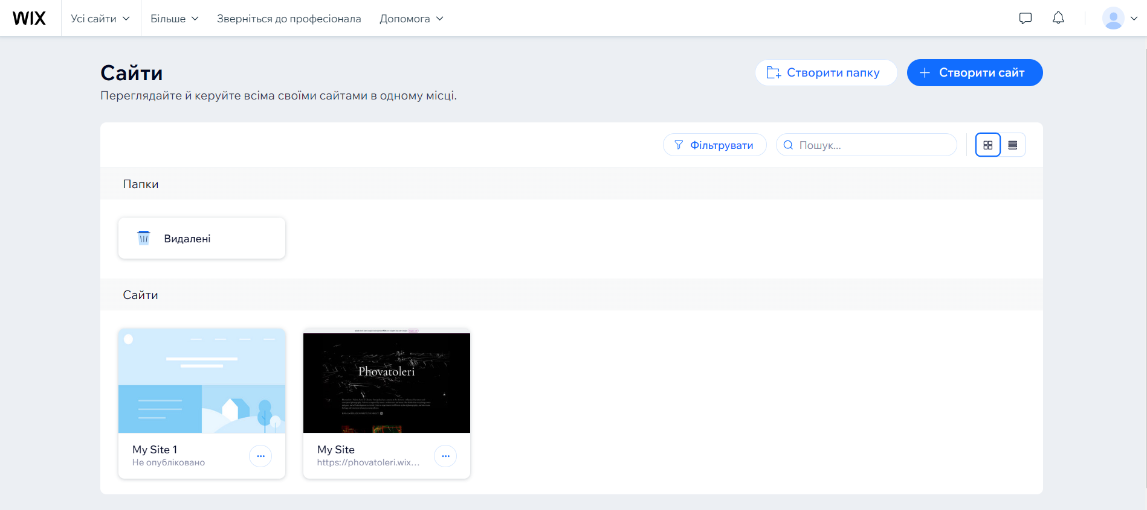
Figure 2.3 – An example of non-profit website

3) NGO/Non-Profit Websites. Just like brands and businesses, Non –profit organisations and NGOs also require a website. Similarly that organisations need sites to be their online nearness, not-for-profits do too. A nonprofit website is the most straightforward path for some potential contributors to give donations and to know more about an Organisation to make their mind about whether or not will they make the donation. On the off chance that we are thinking about beginning an NGO, at that point assembling a site for our association is an essential advance in demonstrating our authenticity and contacting more individuals. We can utilise it to advance the ventures our association handles, urge devotees to make a move, and for accepting donations. Most of the times, the budget for building a nonprofit website is meagre (no budget in some cases). So, we can utilise some open-source tools like the fermium version of Wix or Wordpress (Fig. 2.3) [5].
4) E-Commerce Websites. The websites where users can shop and makes purchases are called E-Commerce Websites. All of would have used these sites a myriad of times, and they have become a must-have for every selling business. With the advancement in website development technology, it has become relatively easy to build an E-Commerce site and start selling. The best way to build an E-Commerce Site is through Shopify, which allows to incorporate all the essential shopping features such as an inventory display, a shopping cart and a payment gateway into website. Other than Shopify, we can also use tools like WooCommerce and Weebly to build a sophisticated store with numerous products. A groundbreaking E-Commerce website example is BeardBrand (Fig. 2.4). This website is built on Shopify and has emerged one of the most successful sites ever made on it [5][9].

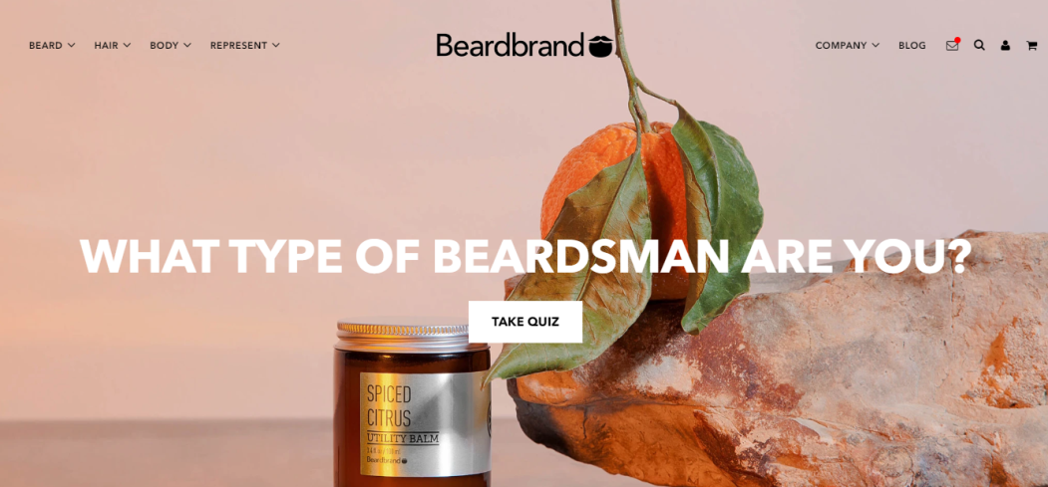
Figure 2.4 – An example of e-commerce website

5) Educational Websites. The sites of educational organisations and those providing online courses fall into the class of educational sites. These sites have the essential objective of either giving study materials to visitors or giving data on an educational organisation to them. Some educational sites will have ads like entertainment and media sites do. Some offer membership models or educational items for procurement. What's more, some fill in as the digital presence for an educational organisation. As a result of the expanding interest for these sites, numerous reasonable apparatuses offer this utility. Ordinarily, a knowledge base feature will be incorporated as a piece of online tools, for example, ZenDesk, Intercom, or Freshworks. Be that as it may, the are some web builders like Wix that offer this usefulness out-of-the-crate. Academic Earth (Fig. 2.5) has a beautiful website that provides many online courses and along with it gives information about various universities [5][9].


Figure 2.5 – An example of educational website

6) Entertainment Website. Entertainment sites contain consistently refreshed substance on current undertakings, climate, sports and amusement. News destinations like CNN and entertainment biggies like ELLE both fall into this classification. The content on media locales is dynamic, which means it's refreshed normally. Enormous media locales will distribute numerous articles and recordings each and every day. The majority of these sites do mean to make cash like business and e-commerce sites do, yet for the most part through the ads that appear on the page as opposed to through selling explicit items or services. Since such websites need to be highly dynamic, we can use platforms like Dreamweaver, WordPress, or Blogger, or we can get it built professionally from a skilful web development company. Elle is one of the most influential beauty magazines, and their website speaks for itself. It's minimal yet so elegant (Fig. 2.6) [5].

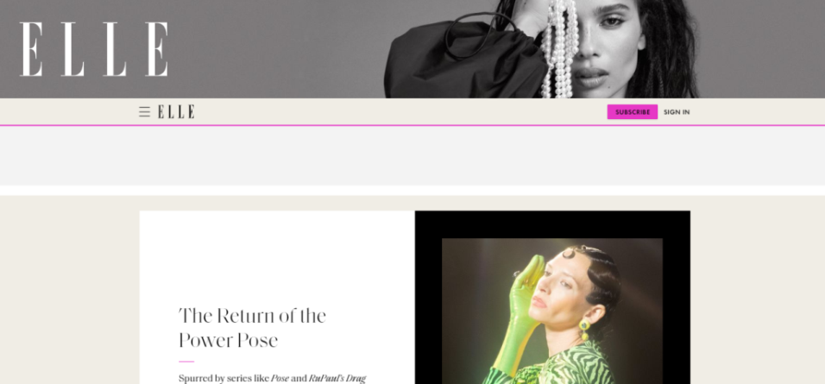
Figure 2.6 – An example of entertainment website

7) Portfolio Website. Portfolio Websites are great for showcasing our work; everyone pro photographers to models are utilising such sites to flaunt their work to potential clients. Essentially utilised by those in the creative business, a portfolio site can be utilised like a CV, showing our abilities so as to dazzle customers, clients, or future prospects. To assemble a noteworthy portfolio that enables our work to stick out, we need a powerful website builder like Squarespace. This platform has the best apparatuses for every web designer, letting we make a fantastic looking webpage in a few hours. Portfoliiobox, Wix and PageCloud are some other excellent alternatives. Yuko Takahashi, an artist, photographer and designer, has gone a step ahead in building his portfolio (Fig. 2.7). Any visitor landing on his page will be mesmerised by its aesthetics and will be compelled to hire him immediately [9].
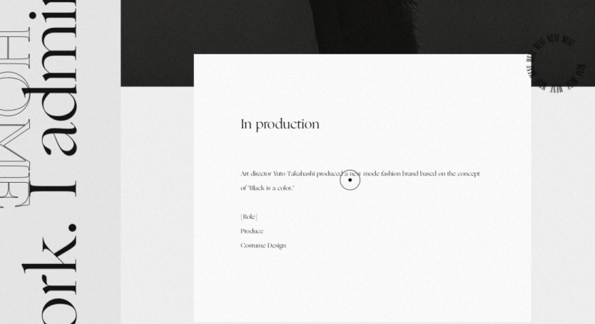
Figure 2.7 – An example of portfolio website

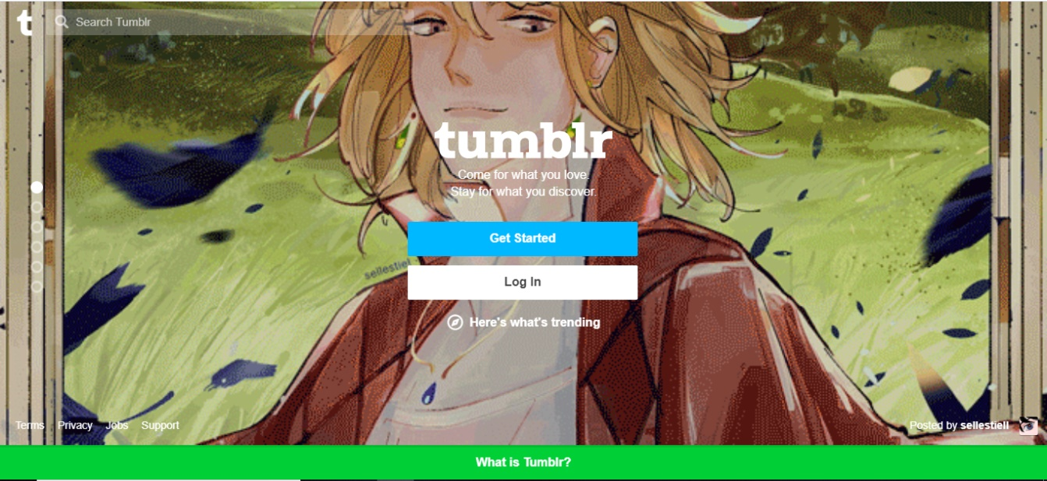
Figure 2.8 – An example of social media website

8) Social Media Websites. Social media comes in various forms. These websites are normally made to let individuals share contemplations, pictures or thoughts, or just associate with others corresponding to a specific topic. Social media websites are progressively turning into the go-to goal for individuals to find out about the news, shop and connect with people. Social media is creating a substantial impact in every domain. On the off chance that sooner or later we had a thought for the next incredible social media website and were restricted by a shoestring spending plan, we could investigate Ning or Social Engine which permit we to begin with a limited budget for our groundbreaking plan for a new social media site. Tumblr is a renowned social media site which allows people to share whatever they want (Fig. 2.8); Comprising of almost 4890 lakh blogs, it is literally an assortment of everything that we can think of [9].

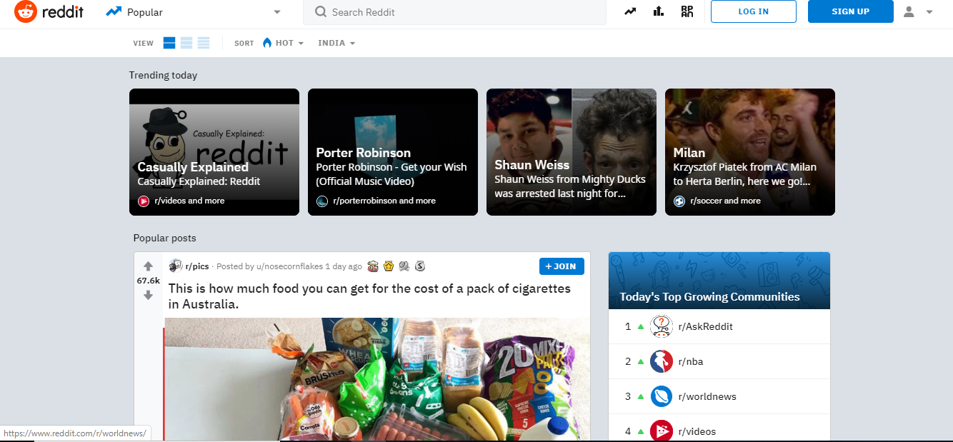
Figure 2.9 – An example of forums

9) Forums. Network or Social Forums are an incredible method to connect and share thoughts with individuals with similar interests or from comparative foundations through the internet. This intelligent element can be the fundamental focal point of the site or only a piece of it with the goal that guests can talk about what the site is about. In spite of what we may be figuring, constructing a forum isn't excessively troublesome or costly. Wix Forum and WordPress both make it truly moderate to make a forum that can be incorporated into our current Wix or WP site. In case we are searching for something which is progressively customized to the requirements of forum users and that can be coordinated into pretty much any site. Reddit calls itself as the front page of the internet and is one of the most popular forums to have ever existed (Fig. 2.9). Registered members can submit any sort of content on any topic whatsoever [5].

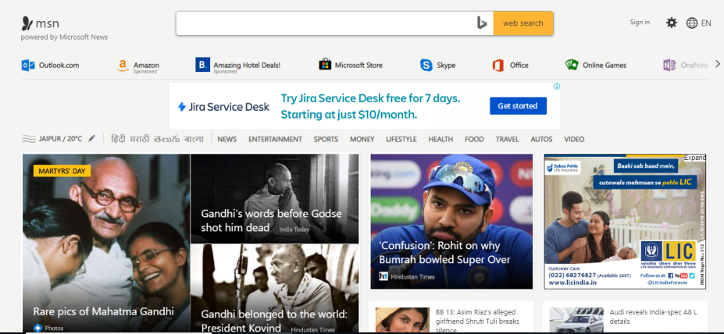
Figure 2.10 – An example of web portal

10) Web Portals. Online interfaces or Web Portals are sites intended for internal purposes at a business, association or an organisation. They gather data in various configurations from various sources into one spot to make all crucial data open to the individuals who need to see it. They frequently include a login and customised views for various users that guarantee the data that is open is generally helpful to their specific needs. Web Portals can be efficiently created using either Joomla or Drupal as they both have the plugins required to develop a web portal using various modules and components (Fig. 2.10). MSN is a popular web portal that brings in information from a variety of sources like e-mails, search engines and online forums [5][9].
Analyzed and researched the types of sites, we can conclude that we will create an online store. In this way, the company will be able not only to demonstrate its works, but also to actively sell them.

2.2 Ways to create online stores

An online store enables you to present yourself in the best possible light. It functions as a comprehensive platform for selling advertised products, offering essential information about the store's features and services. Consequently, an online store should be unique, user-friendly, and easily accessible. The information provided on the online store must always be accurate and regularly updated.
There are various methods available for developing an online store, each with its own set of pros and cons [2]. The most commonly used methods have been examined (Fig. 2.11).
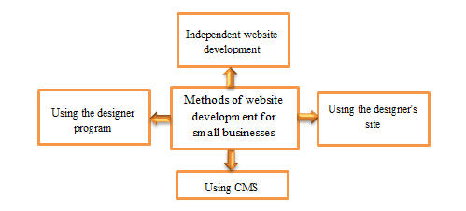
Figure 2.11 – Common methods of creating a website for a small business

The first method is independent development of an online store. This method consists in the fact that it is necessary to independently install the necessary software tools for writing an online store in one or more programming languages ​​(PHP, React, JavaScript, etc.).
At the same time, work can be done both in simple (text) and visual HTML and CSS editors. The latter allow you to develop an online store in WYSIWYG mode - "What I See is What I Get".
The second method is with the help of CMS. This method of creating an online store is one of the most popular today. You can create an online store on such a system automatically by prematurely installing the CMS platform. It is a ready-made visual and software shell, which only remains to be filled with the necessary content, but the shell can be changed and customized at will.
The third method is with the help of a site-builder. Site builder is a web resource that allows you to create an online store of any type as simply and quickly as possible in just a few minutes: business card, landing page, online store.
The fourth method is using the designer program (visual editor). Site builder is a special program that is installed on a computer to help in writing the code or allows you to completely generate the code of any elements of the online store [2].
When examining the four common methods of developing an online store, we can conclude that the first method is reliable, but requires constant updating and protection. The second method is very convenient, but has security issues. The third method has limited capabilities, but is quick and easy to use for simple online stores. The fourth method simplifies the writing of an online store, but may have limitations in terms of dynamics and configuration of additional functions. Due to a uniquely crafted design, along with a range of functions, animations, and other features. The future website will stand out from others and have better recognition.

2.3 Architecture of client and server parts

Creating a website consists of two parts: front-end and back-end (Fig. 2.12) [4].
Frontend development is creating the user interface on the website or application side. It's everything a user sees and interacts with when they open a web page: buttons, banners, and animations [2]. Components of front-end development:
HTML (HyperText Markup Language) is a document markup language used to create a page structure: headings, paragraphs, lists, etc.
CSS (Cascading Style Sheets) is a language for describing and styling the appearance of a document. Thanks to the CSS code, the browser understands exactly how to display the elements. For example, CSS sets the colors and font parameters, determines how the various blocks of the site will be arranged.
JavaScript is the language that brings web pages to life. Its task is to respond to user actions, process mouse clicks, cursor movements, and keystrokes.
The backend is the development of the business logic of the product (website or web application). The backend is responsible for user interaction with internal data, which is then displayed by the frontend. Components of back-end development:

The backend developer uses the tools available on his server. He has the right to choose any of the universal programming languages ​​– for example, Ruby, PHP, Python or Java. Everything depends on the specific project and task of the customer.
Database management systems are also used for back-end development:
- MySQL;
- PostgreSQL;
- SQLite;
- MongoDB.
- Download tools (deploy) are also used:
- CI/CD;
- Kubernetes (K8s);
- Docker.

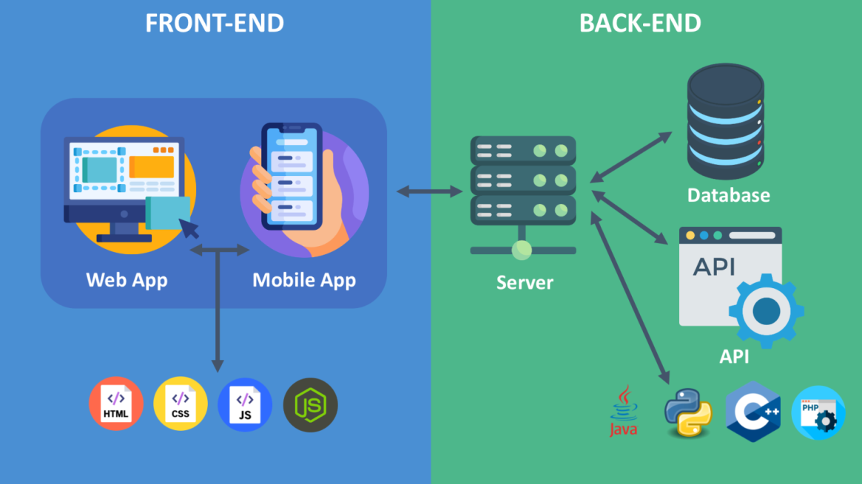
Figure 2.12 – Two parts of creating website: Frontend and Backend

The site can also be divided into a client part and a server part [4]:
Client-Side:
- Web Interface. A website has been created for the convenient use of clients. Clients have an intuitive and user-friendly interface for viewing products, adding them to the cart, and placing orders.
- Authentication and Security. Data and user security have been ensured using the HTTPS protocol, encryption, and an effective authentication system.
Service-Side:
- A payment system has been added to ensure the security of transactions on the site. Networking involves data exchange and communication between different organisations and communities.
- Computer networks are evolving continuously, thanks to new technological innovations and advancements. Notable innovations include satellite internet, cloud, 5G technology, and blockchain, to name a few. Client-server architecture, also known as the client-server model, is one of the prime concepts of computer networks. Most networks today depend on this model for its higher efficiency and enhanced performance.
Client-Server Architecture is a computer network where clients request and receive services and files from a centralised server over a local internet connection. A client uses an application as an interface to connect to the server. Once the connection is established, the server processes operations and information storage. [7]
This client-server model is a network application that breaks down workloads and tasks between servers and clients present on the same system or connected via a computer network. The architecture features multiple PCs, users’ workstations, or other devices, all connected to a central server via the internet or some other network connection.
Once a client sends a request for data, the server accepts and processes the request and then sends data packets back to the user who sent the request. This model is also known as the network computing model or client-server network.
Prime Components of Client-Server Architecture. The client-server architecture is similar to the request-response pattern and has a standard communication protocol defining communication rules and language.
Varieties of Client-Server Architecture. The service of the client-server model is spread across different tiers:
- 1-tier architecture. In an all-in-one system, 1-tier architecture, a data logic system, a user interface environment, a marketing logic system and a client/server installation setting are all stored on a shared storage device or a single device [7]. Though the wide range of services is trustworthy, managing this architecture is challenging.
Because of the irregularity of data, there are duplicated efforts. One of the best examples of 1-tier architecture is a desktop application working offline, and data storage occurs on the same device it runs.
- 2-tier architecture. The 2-tier design provides the best client/server environment. In the two-tier architecture, the user interface or UI is stored on the client system, while all the databases are saved on the server computer. Preserving both business and database logic is essential, whatever their storage destination [7]. Responses are quick in the 2-tier architecture in DBMS as there is direct communication between client-server devices when the client places the order.
- 3-tier architecture. In the 3-tier client-server architecture, the server and the client have middleware lying between them. When the client requests the server to fetch some information, the middleware receives the request, which is then forwarded to the server for further action. The exact same chain follows when the server responds to the client. The client machine handles the presentation layer management, the middleware handles the application layer management, and the server manages the database layer [7].
- N-tier architecture. Also known as multi-tier architecture, it is a scaled form of two-tier and three-tier architecture [7].
In this architecture, each function is located as an isolated layer, including application processing, presentation and data functionality management.
Functioning of Client-Server Architecture. A client-server architecture has a client node and a server node. While the server functions as the producer, clients are considered consumers. A consumer sends a request to the server via a network. After processing, the consumer gets the final data per the submitted request [7]. Explanation of the functioning of the client-server model:
- When a user puts in any file or website’s URL, the browser sends this request to the Domain Name System (DNS) server.
- The DNS server looks for the web server’s address.
- The DNS server replies with the IP address of the web server.
- The browser sends HTTPS or HTTP requests to the IP address of the web server.
- The server sends the required files for the website.
- The browser provides the files, and we have the website displayed. The rendering is completed with the help of a CSS interpreter, DOM interpreter and JS Engine.
The Objective of Client Server-Architecture. Business organisations nowadays need a system to collect, process and act on corporate data efficiently. With the client-server network model in place, there is a higher level of processing, thus increasing the effectiveness of workgroup empowerment, workstation power, market-driven business, remote network management, etc [3].
With client-server architecture, businesses get the exact framework for meeting the challenges of the fast-paced and ever-evolving IT world.
Prominent Features of Client-Server Architecture. A client-server model has the following characteristics:
- A single computer server can provide multiple services simultaneously. However, each service will need a separate server program.
- Server and client machines need different and separate software and hardware resources from different vendors.
- There is a requirement for a complete stack of protocols for both server and client computers. The transport protocol needs lower-layer protocols for receiving and sending individual messages.
- Both server and client applications have direct interactions with the transport layer protocol. This process not only establishes communication but also helps entities in sending and receiving information.
- Real-Time Instances of Client-Server Architecture. Some real-life client-server architecture examples:
- File servers. We use file servers to store files on various cloud-based services like Microsoft Office or Google Docs. Multiple clients can access these servers, which are centralised locations for file storage.
- Web servers. These are high-performance servers hosting a plethora of different websites. Clients access web servers via the internet.
- Email servers. Emails have become the primary mode of corporate communication owing to their speed and ease. Email servers help seamlessly receive and send emails between different parties [7].
- Understanding the Merits and Demerits of Client-Server Architecture. Advantages of the client-server model:
- IT staff have access to changing server and client capacities separately.
- It is a centralised system where all controls and data remain in one place.
- It permits data recovery.
- It brings in high levels of efficiency, organisation and scalability.
- It is cost-efficient, particularly when it comes to maintenance.
- It optimises performance with load-balancing.
- The setup minimises the chances of data replication.
- It permits various platforms to share resources.
Disadvantages of the client-server architecture:
- In case a critical server goes down, consumers are at a loss.
- Data packets can be modified or spoofed during transmission.
- Initially costly to start up and implement.
- The server is vulnerable to DoS attacks, phishing and Man-in-the-Middle attacks.
Users might be affected if the server has a virus or Trojan, as the network has linked servers and clients.
Understanding 3-Tier Client-Server Architecture. The 3-tier client-server architecture comprises a User Interface layer (presentation tier), a Service layer (application tier) and a Database server (data tier) [7].
The client system controls the Presentation layer, the Application server handles the Application layer, and the Server system supervises the Database layer. Peer-to-peer networks are also called P2P networks. These networks have a group of computers linked in a network, where peers are both the server and the client. Peers have the same permissions and responsibilities to work with the available data [7]. However, the client-server model has defined groups of servers and users.

Table 2.1 - The differences between the two models
Client-server. | Peer-to-Peer.
Higher security levels. | Users are responsible for the security.
Requires a central file server which is expensive to implement. | Does not require a central file server.
Slower. | Faster and easier than client-server networks.
Have separate users and providers. | Peer-to-peer networks act as providers and consumers.
Have more scalability and stability. | The ideal range is 2 to 8 users.
The crashing of a client-server network stops everything. | A single node might fail, keeping other things operational.

A conceptual model, system architecture specifies the behaviour and structure of a system. On the contrary, server architecture is a high-level structure which specifies the responses for meeting business and technical goals while maximising the quality of the software.
The system architecture includes hardware and software parts and is used for designing a composite system [4]. Server architecture considers business strategy, human dynamics, design, quality aspects, IT architecture, etc.
Networking is inevitable for business organisations to establish strategic alliances by exchanging data and communication. The client-server architecture lets multiple users update a shared database via a graphical user interface. This fundamental networking concept is used in many industries for improved data organisation, centralised file storage, and better management [4].

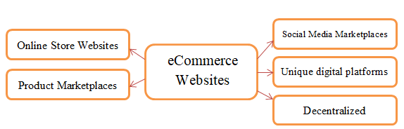
Figure 2.12 – Types of eCommerce websites

Studied the types of eCommerce websites, it is possible to say that the customer's requirements will suit exactly Online Store Website. I also chose to create a website independently, according to the client's requirements. Since the client wants to achieve a unique minimalistic and concise design with quality images, as this is the main focus of the product.

2.4 Types of online store publication

Ecommerce is the buying or selling of goods and services over the internet. This form of business is done through websites, which facilitate the exchange of money, and transfer of information. It’s convenient to shop from the comfort of home, and we can do it at any time of the day [2][3]. It can include anything from buying a pizza to purchasing a new car.
The first known instance of an eCommerce website was when a man named Michael Aldrich put a copy of a music CD by a band called “Sting” up for sale on his website, “Net Market”, in 1994. This marks the first instance of a consumer purchasing something online.
Ecommerce has become easier to use over time, with more retailers and marketplaces offering products online. Ecommerce has enabled businesses of all sizes to sell their wares online, and this has resulted in increased sales for all of them.
Benefits of E-Commerce. E-commerce provides many benefits for both shoppers and businesses [3]. For shoppers, e-commerce offers convenience, personalization, and a global marketplace. For businesses, e-commerce minimizes expenses and allows for easy entry into the market.
Types of E-commerce business models:
1) Business to business (B2B) - When a business is selling goods or services to another business.
2) Business to consumer (B2C) -When a business is selling a product or a service directly to the consumer.
3) Consumer to consumer (C2C) - When a consumer is selling a product or service to another consumer.
4) Consumer to business (C2B) - When a consumer is selling their own products or services to a business or organization.
E-commerce platforms. Now that we’ve looked at the types of e-commerce businesses out there, let’s examine the platform they’re using:

2.4.1 Online Store Websites
The first place we should show our products and services is on our site. Using online shopping carts and ecommerce websites, we can build online stores that make it easy for customers to find and buy our products. We don’t need to hire a developer or be a techie to build a website [3]. There are lots of website builders out there that make it easy:
- Shopify. Over 3,766,071 eCommerce websites use Shopify to power their online stores. This accounts for over 32% of the e-commerce market, making the company a clear leader in the industry. This eCommerce solution is one of the most popular eCommerce platforms for beginners and small business owners since it allows them to set up their online store in just a few days [3].
- Magento. As of today, over 772,000 businesses worldwide use Magento to power their websites. This popular open-source e-commerce platform is used by medium to large companies looking to scale up. It offers a number of customizable options, such as the ability to design our own template, install extensions, and create automated workflows. There are over 5,900 different plugins and modules available to extend the functionality of magento store. With that many options to choose from, we should be able to find exactly what we need [3].
- WooCommerce. This content management system (CMS) is powering over 5,102,506 active websites and over 1,773 WordPress plugins designed to integrate seamlessly with it can be purchased on CodeCanyon. Woocommerce is an open-source platform that’s designed to work seamlessly with the blogging software, WordPress. With plenty of free and premium themes, WordPress’ eCommerce plugin, Woocommerce, can help us create a unique online storefront [3].
- Carrd. While it’s not built for eCommerce, Carrd is a platform that allows us to create simple, single-page websites. This e-commerce platform is for freelancers or artisans who want to run their own businesses. It only takes a few minutes to set up, and it’s easy to use. And the reason why it’s relevant to us is that it covers a segment of the digital market, which is over 800,000 sites strong.

2.4.2 Product Marketplaces
Online marketplaces provide a convenient platform for buyers and sellers to connect with each other. Sellers can showcase their products to a wider audience, while buyers can enjoy greater convenience and choice when shopping online.
Marketplaces, like Amazon, are a popular option for customers looking to buy from a variety of different vendors. In an online marketplace, we have a wider range of products to choose from than we would if we were shopping on the brand’s website [3]. We can also find better deals on products since retailers are competing with each other for business. Some of the places we can find freelancers are:
- Amazon. The well-known company, Amazon.com, is the world’s largest online retailer, with a projected 2021 annual revenue of $469.8 billion dollars.
Amazon has over 200 million subscribers in the US alone, who, on average, spends $1,400 per year on online shopping. Amazon has millions of products for sale from thousands of sellers. It’s one of the biggest marketplaces in the world.
- eBay. With 1.5 billion listings and 147 million users, the online marketplace, eBay, has a massive impact on online shopping. With eBay, small businesses can establish a global presence easily and affordably. The easy-to-use interface and payment options make eBay the perfect platform for small businesses looking to establish themselves internationally. The unique auction system makes buying and selling more fun and interactive.
- Etsy. In 2020, there were 2.7 million people selling on Etsy, and 45.7 million users buying. There were also 60,000,000 listings. For creative types, there’s no better place than Etsy to sell handcrafted goods. It attracts thousands of buyers every day, and is especially popular with people who like to buy unique and hard-to-find merchandise.
- Alibaba. The eCommerce platform, AliExpress, is a subsidiary of the much larger Chinese company, the Alibaba Group. The marketplace offers suppliers the opportunity to sell products to buyers around the world. With 960 million users, the Chinese marketplace, Ali Baba, is the world’s largest. Alibaba is the top dog in China with an impressive 960 million active customers.

2.4.3 Social Media Marketplaces
There are over 4.62 billion people using social media around the world. Brands are using social platforms like Facebook and Instagram to sell directly to their customers. Social platforms are making it more difficult for marketers to drive traffic to their websites, but they’ve started to allow businesses to sell their products and services directly on their networks. Instagram is a great place to find new products, and now with the checkout feature, we can buy the items we like without even leaving the app! This makes it easier than ever to get our hands on the latest trends and styles. Facebook has been a popular marketplace for selling and buying products for years [3].
But now, businesses can launch Facebook Shops that integrate with their Instagram accounts. This makes it easier for customers to find and purchase products they’re interested in. Selling on Pinterest is a great way to sell products to a large audience. We can upload our entire catalog of items, create pins that contain products, and link them to online shop. Social media platforms are becoming more and more popular for marketing, and this is also true for e-commerce. This is because these platforms provide a great platform for building brand and for running campaigns. Additionally, we can use these channels for selling products.

2.4.4 Unique digital platforms
These are eCommerce platforms that allow entrepreneurs to set up shop and sell their goods online in unique, decentralized ways. If we are looking to build our own online courses, check out platforms like Gumroad or Podia. If we want to create and monetize a premium email newsletter, try a platform such as Substack.

2.4.5 Decentralized Commerce
The blockchain is an internet protocol that enables users to have control over their online data. There has been much hype surrounding this emerging technology, as it has the power to change how we use the web.
In the ecommerce industry, there are a few platforms in development that can potentially impact the future of selling and buying online. A pair of them include DAOs and NFTs marketplaces. DAOs, or Decentralized Autonomous Organizations, are organizations run by code and where the stakeholders make decisions with votes using unique tokens. Currently, there’s a DAO called “The DAO” that offers “borderless commerce” to enable worldwide payments without regulatory hassles and integrate it with our store. NFTs, or Non-fungible tokens, are individual currencies often tied to a specific document such as an image, video, audio, certificate, or any type of file. As of now, there’re NFT marketplaces where people can publish and trade their own NFTs, the most popular being OpenSea [3].
Starting an eCommerce website is not as easy as just opening a store and selling some products. We need to put in a lot of work to get people to visit our site and buy from us [2]. There are steps we can take to ensure the success of our retail store:
- Focus on users. With eCommerce websites, we can literally sell anything we want to, but it’s important that we know how to build trust with our website visitors. To create an effective website, we should consider the website’s theme, branding, and tone of voice. Additionally, we should focus on one or two target audiences to avoid becoming overwhelmed.
- Get feedback. Have a friend go through the buying process to make sure there are no glitches. We don’t want to make the purchasing experience so long that people will abandon their cart before they’ve placed their order.
- Be mobile-friendly. Optimizing online store for mobile and tablets is becoming more and more important. With more and more people using their mobile devices to shop online, it’s important to make sure the store is optimized.
- Invest in SEO and PPC. If we want eCommerce store to be successful, we need to invest in SEO and PPC. These two things will drive traffic to store and help achieve goals. If we don’t have the budget for a consultant or agency, then learn about eCommerce SEO and apply relevant strategies to store.
- Research and develop. Don’t just sell the same products over and over. Research new products and services to sell. We don’t have to constantly be adding new items to online store. Try to find ways to make store stand out through innovative means. Future of E-commerce industry. The e-commerce industry is forecasted to continue expanding. In 2021, online sales are predicted to make up 18.1% of all retail purchases.
The e-commerce industry is forecasted to continue increasing its share of total retail sales. This is good news for those wanting to open an online store as more and more consumers turn to online shopping. However, this also means more competition for online businesses [9].
This is good news for those wanting to sell online as e-commerce sales are only expected to go up, but so will the competition. Virtual reality may one day be the future of eCommerce. Imagine being able to virtually ‘try on’ clothes in a store! This will enable customers to see how the clothing will fit their body shape, as well as try on make-up using their phone or computer screen. The eCommerce industry is evolving rapidly, and we’re excited to be part of it [9].
After analyzing exactly what type of store will be from the e-commerce side, we can understand that for the company Phovatoleri will be the best these two types of e-commerce: Online Store Websites and Social Media Marketplaces. But the customer wants the creation of a site on which he will sell his products, that is why we choose the Online Store Website type. Since this company currently has a small number of products, Unique digital platforms and Decentralized Commerce, and Product Marketplaces are definitely not suitable for us.

3 CREATION OF THE INTERNET STORE

3.1 Installation and configuration of the necessary instrumentation

In the requirements, the customer emphasized the creation of the front-end part. Front end is divided into: the creation of a layout and templates for the site, HTML and CSS layout, creation of visualization and animation. There are various programs with which you can write code, markup language and cascading style sheets, here are some of them [4]:
- Sublime Text.
- Visual Studio Code.
- Atom, etc.
Comparing programs, for this project I used Visual Studio Code because the program is considered universal (it can be written in many languages), and it is also very convenient to use (Fig. 3.1) [7].
The creation of the front-end part consists of several elements: the HTML markup language, cascading CSS style tables, the use of CSS preprocessors (optional) and JavaScript.
There have been several versions of HTML since 1993. Currently, there are more than 5 versions of HTML: HTML 1.0, HTML 2.0, HTML 3.0, HTML 4.01, XHTML, HTML5. Analyzing the release dates of the versions, we can assume that the latest version will be better, namely the HTML5 version [7]. It has more built-in functions and capabilities. This version was chosen for this project.
In CSS, levels are denoted as CSS1, CSS2, and CSS3. The next level of CSS is built on top of previous ones, adding new functionality or extending existing functionality. Therefore, I used version CSS3.
Using a CSS preprocessor makes code easier to write and read. There are the following types of preprocessors: Sass and SCSS. Therefore, I chose SCSS because it is similar to CSS. This makes it easier to convert CSS files to SCSS.

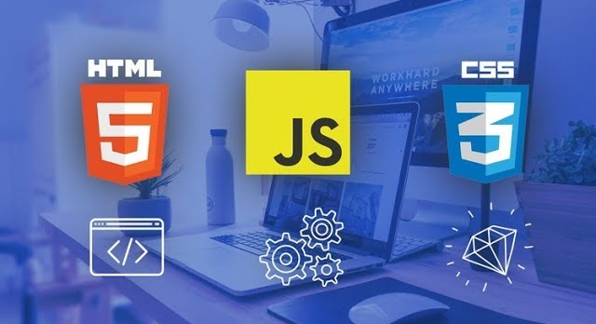
Figure 3.1 - Selected programs for the development of an online store

3.2 Development of the online store mockup

A mockup is a static design of a web page or application that features many of its final design elements but is not functional [4]. There are several main programs to do the mockup: Figma, Mockplus, Marvel, UXPin, MockFlow.
All programs are modern, but for the company Phovatoleri I used Figma program. It is this program that has more advanced features and is easier to use.
According to the functions performed by the navigation system:
- language selection.
- language navigation of the site. With the help of this type of navigation on the site, the visitor can choose which of the possible display languages ​​he wants to use;
- the main important sections of the site or its pages are placed in the main navigation of the site (for example, the main menu);
- the global navigation of the site contains links to pages that should be accessible from any page of the site. For example, a link to the home page;
- to navigate through sections, categories or pages of the same topic, thematic navigation is used;
- to ensure the possibility of direct transition from the page of the site being viewed to another mentioned in the text of this page, navigation in the text of the site is used.
By type of visual design:
- test - text navigation on the site, the most "old" type of navigation, used mainly for text navigation, less often for other functions;
- graphics - graphic navigation is the most popular and is used for all functional types of site navigation;
- HTML-Forms - this type of navigation allows you to save space due to the elements that open; this type of navigation often uses DHTML visual effects;
- Java and Flash technologies - this type of navigation allows you to set any reaction to user actions: hovering the cursor, pressing the mouse button,"hot" keys.
Analyzing the functions performed by the navigation system and types of visual design to meet the customer's requirements, I used the main website navigation, section navigation, text navigation and graphic navigation (Fig. 3.2, Fig. 3.3). This can see the applied navigations in point 3.3.
The Phovatoleri online-store layout:
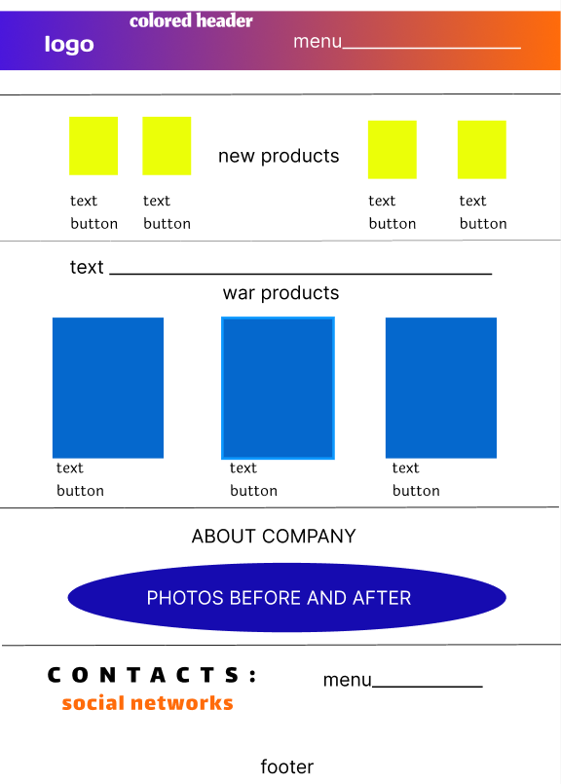
Figure 3.2 - The layout of the main page on the future website

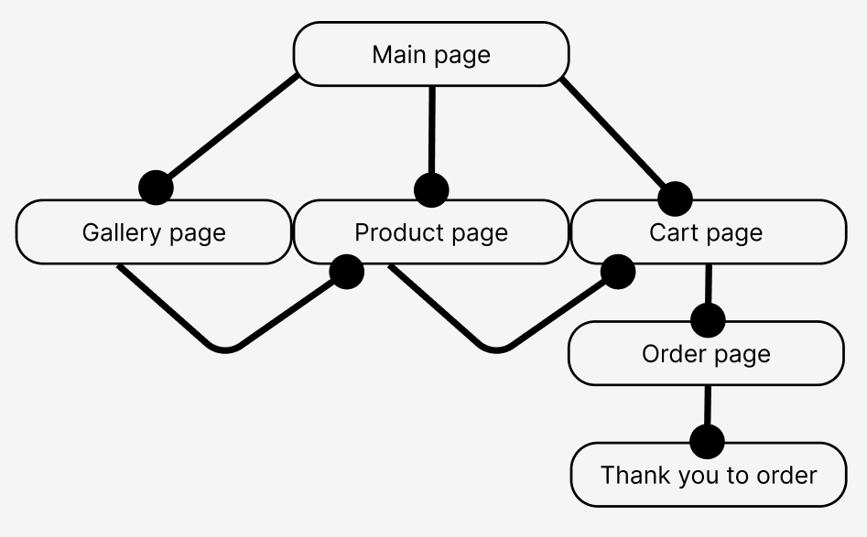
Figure 3.3 - The mockup of the future website

3.3 Development of the structure (navigation/menu) of the online store

The menu navigation of the online store Phovatoleri is developed in the following sequence (Fig. 3.4, Fig. 3.5, Fig. 3.6, Fig. 3.7): Gallery, War, About us, Cart (with icon).


Figure 3.4 – The menu navigation in online store Phovatoleri

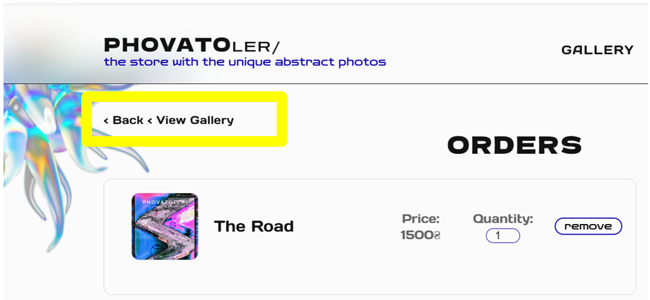
Figure 3.5 – The navigation section (in the yellow rectangular)

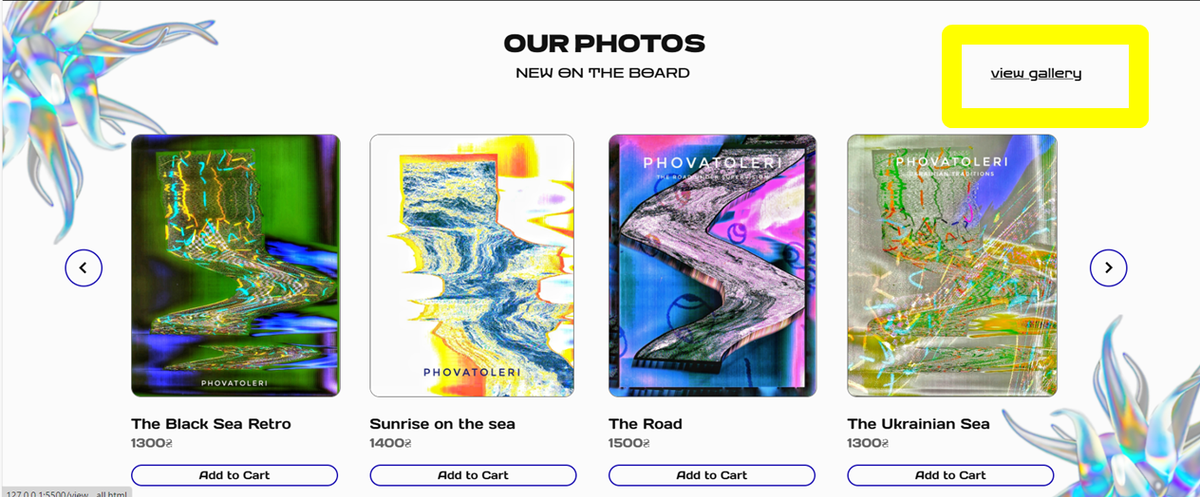
Figure 3.6 – The text navigation (“view gallery” in the yellow rectangular)


Figure 3.7 – The graphic navigation (the arrow in the yellow square)

3.4 Development of the design and logo of the online store

For the online store Phovatoleri, I created a minimalist design, as specified in the customer's requirements. The design was created in the Figma program. And also were chosen the following fonts: Days One (regular), Dela Gothic One (regular), Zen Dots (regular). The following sizes are: 20px, 18px, 16px.
The logo has been created in the Figma program. It is written by Dela Gothic One (regular) and Zen Dots (regular) fonts with size 28px and 20px (Fig. 3.8).
The main phrase of the store is written by Zen Dots (regular).


Figure 3.8 – The logo for the online store Phovatoleri

3.5 Development of the main page

The main page contains:
- Header: logotype, navigation menu (Gallery, War, About us, Cart), shopping cart icons (Fig. 3.9, Fig. 3.10, Fig. 3.11).

Figure 3.9 – The header in the online store Phovatoleri

<header id="header" class="header">
<div class="page__" data-glow>
<div class="container">
<div class="header__inner">
<div class="header__inner-logo"><a href="/index.html">Phovato
<span class="header__inner-logo-valeria main">ler/</span></a>
</div>
<div class="text-3">The store with the Unique abstract photos</div>
<nav class="menu menu__btn">
<ul class="header__menu">
<li><a href="/view__all.html"class="header__menu__gallery">Gallery</a></li>
<li><a href="#war__products" class="header__menu__war">War</a></li>
<li><a href="#about__us" class="header__menu__about__us">About us</a>
</li>
<li><a href="/cart.html" class="header__menu__cart">Cart</a>
<div id="cart-count" class="count">0</div>
</li></ul></nav>
</div></div> </div>
</header>
Figure 3.10 – The HTML code for the header

$(function() {
$('.menu__btn').on('click', function(){
$('.header__menu').toggleClass('header__menu--active')});});
"use strict"
window.addEventListener('load', windowLoad);
function windowLoad() {
if (document.querySelector('[data-glow]')) {
document.documentElement.addEventListener('mouseover', buttonActions);
document.documentElement.addEventListener('mouseout', buttonActions);
document.documentElement.addEventListener('mousemove', buttonActions);
let bGlow, bGlowColor, bGlowSize;
function buttonActions(e) {
const button = e.target.closest('[data-glow]');
if (!button) return;

if (e.type === "mouseover") {
button.insertAdjacentHTML("beforeend", `
<span class="glow"><span class="color"></span></span>`);

bGlow = button.querySelector('.glow');
bGlowColor = button.querySelector('.color');

bGlowSize = Math.min(button.offsetWidth, button.offsetHeight);
bGlow.style.width = bGlow.style.height = `${bGlowSize}px`;

bGlowColor.style.width = `${button.offsetWidth}px`;
bGlowColor.style.height = `${button.offsetHeight}px`;
}
if (e.type === 'mouseout') {
button.querySelector('.glow').remove();
}
if (e.type === 'mousemove') {
const posX = e.pageX - (button.getBoundingClientRect().left - scrollX);
const posY = e.pageY - (button.getBoundingClientRect().top - scrollY);

bGlow.style.left = `${posX - bGlowSize / 2}px`;
bGlow.style.top = `${posY - bGlowSize / 2}px`;
bGlowColor.style.transform = `translate(
${posX - (button.offsetWidth - bGlowSize / 2)}px,
${posY - (button.offsetHeight - bGlowSize / 2)}px)`;
}}}}
Figure 3.11 – The JavaScript code for the header

- Main content: new products (image + name + price + button Buy) (Fig. 3.12, Fig. 3.13, Fig. 3.14, Fig. 3.15).

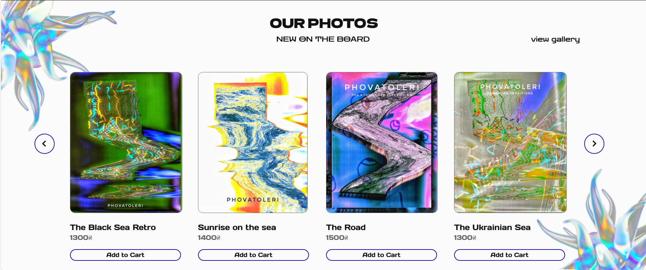
Figure 3.12 – The first section on the main page in the online store (slider)

<section id="products__new" class="products__new">
<div class="page">
<div class="decor1"></div>
<div class="decor2"></div>

<div class="container-products">
<div class="products__inner">
<div class="products__inner-title">Our photos</div>
<div class="products__inner-line2">

<div class="products__inner-line-new">NEW ON THE BOARD</div>
<div class="products__inner-line-view">
<a href="view__all.html" class="link-view-all">view gallery</a></div></div>
<div class="slider">
<div class="slider__item product">
<a href="/product item html/product__green-sea.html" class="slider__item-photo">
<img src="/img/all__photos/Sea/Sea/Sea.png" alt="Photo Sea"></a>
<div class="slider__item-title"><a href="/product item html/product__green-sea.html">The Black Sea Retro</a></div>
<div class="slider__item-price">1300₴</div>
<a href="/cart.html" class="slider__item-buy add-to-cart" onclick="addToCart(1, 'The Black Sea Retro', 1300, 1, '/img/all__photos/Sea/Sea/Sea.png')">Add to Cart</a>
</div>

<div class="slider__item product">
<a href="/product item html/product__sunrise-sea.html" class="slider__item-photo">
<img src="/img/all__photos/Sea/sunrise-sea/sunrise-sea.png" alt="Photo White Sea"></a>
Figure 3.13 – The HTML code for the first section on the main page (slider, part 1)

<div class="slider__item-title"><a href="/product item html/product__sunrise-sea.html">Sunrise on the sea</a></div>
<div class="slider__item-price">1400₴</div>
<a href="/cart.html" class="slider__item-buy add-to-cart" onclick="addToCart(2, 'Sunrise on the sea', 1400, 1, '/img/all__photos/Sea/sunrise-sea/sunrise-sea.png')">Add to Cart</a>
</div>
<div class="slider__item product">
<a href="/product item html/product__road.html" class="slider__item-photo"><img src="/img/all__photos/The-road/The-road.png" alt="Photo The Road"></a>
<div class="slider__item-title"><a href="/product item html/product__road.html">The Road</a></div>
<div class="slider__item-price">1500₴</div>
<a href="/cart.html" class="slider__item-buy add-to-cart" onclick="addToCart(3, 'The Road', 1500, 1, '/img/all__photos/The-road/The-road.png')">Add to Cart</a>
</div>
<div class="slider__item product">
<a href="/product item html/product__ukrainian-sea.html" class="slider__item-photo"><img src="/img/all__photos/Sea/Sea-Ukrainian/Sea-Ukrainian.png" alt="Photo Sea-Ukrainian"></a>
<div class="slider__item-title"><a href="/product item html/product__ukrainian-sea.html">The Ukrainian Sea</a></div>
<div class="slider__item-price">1300₴</div>
<a href="/cart.html" class="slider__item-buy add-to-cart" onclick="addToCart(4, 'The Ukrainian Sea', 1300, 1, '/img/all__photos/Sea/Sea-Ukrainian/Sea-Ukrainian.png')">Add to Cart</a>
</div>
Figure 3.14 – The HTML code for the first section on the main page (slider, part 2)

$(function(){

$('.slider').slick({
slidesToShow: 4,
slidesToScroll: 4,
});
});

Figure 3.15 – The JavaScript code for the first section on the main page (slider)

- Main content: the products is related to the war (Fig. 3.16, Fig. 3.17, Fig. 3.18, Fig. 3.19, Fig. 3.20).


Figure 3.16 – The second section on the main page in the online store

<section id="mariupol" class="mariupol">

<div class="decor3"></div>
<div class="decor__mariupol"></div>
<div class="decor-line-black"></div>

<div class="container">
<div class="mariupol__inner1 reveal">
<div class="first__line">

<div class="mariupol__inner1-title">The war in Ukraine is continues... </div>
<div class="button__line" type="button">
<a href="#header">
<img src="/img/header/arrow-up.png">
</a>
</div>

</div>
<div class="mariupol__inner1-text">We fight <span>independence</span> and
<span>freedom</span>.
</div>
<div class="mariupol__inner2 reveal">
<div class="mariupol__inner2-title1">Glory to Ukraine!</div>
<div class="mariupol__inner2-title2">Glory to our Defenders!</div>
<div class="mariupol__inner2-text">
The next set of works is devoted to the armed terrorist aggression russia
against Ukraine.</div>
</div>
</div>
<div class="decor-line-black"></div>
Figure 3.17 - The HTML code for the second section on the main page
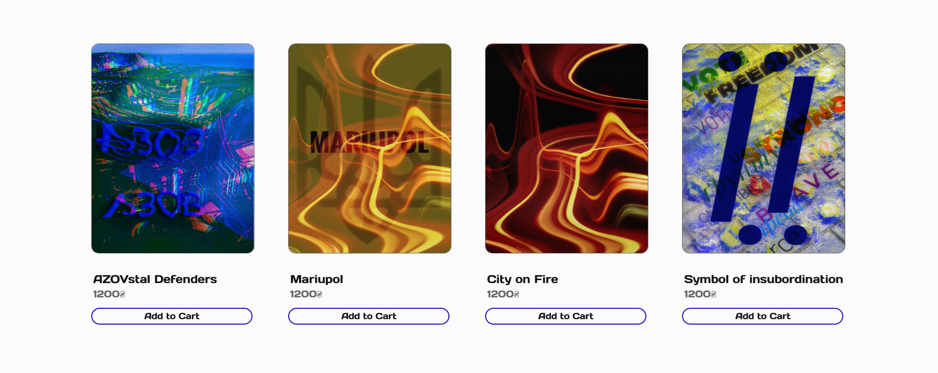
Figure 3.18 – The third section on the main page in the online store

<section id="war__products" class="war__products">
<div class="grid">
<div class="grid__item reveal-photo1 product">
<a href="/product item html/product__azov.html" class="grid__item-photo"><img src="/img/all__photos/azov/Azov.png" alt="Photo Azov"></a>
<div class="grid__item-title"><a href="/product item html/product__azov.html">AZOVstal Defenders</a></div>
<div class="grid__item-price">1200₴</div>
<a href="/cart.html" class="grid__item-buy add-to-cart" onclick="addToCart(13, 'AZOVstal Defenders', 1200, 1, '/img/all__photos/azov/Azov.png')">Add to Cart</a>
</div>
<div class="grid__item reveal-photo2 product">
<a href="/product item html/product__mariupol.html" class="grid__item-photo"><img src="/img/all__photos/mariupol/Mariupol-photo.png" alt="Photo Mariupol"></a>
<div class="grid__item-title"><a href="/product item html/product__mariupol.html">Mariupol</a></div>
<div class="grid__item-price">1200₴</div>
<a href="/cart.html" class="grid__item-buy add-to-cart" onclick="addToCart(14, 'Mariupol', 1200, 1, '/img/all__photos/mariupol/Mariupol-photo.png')">Add to Cart</a>
</div>
<div class="grid__item reveal-photo3 product">
<a href="/product item html/product__fire.html" class="grid__item-photo"><img src="/img/all__photos/fire/fire.png" alt="Photo Mariupol"></a>
<div class="grid__item-title"><a href="/product item html/product__fire.html">City on Fire</a></div>
<div class="grid__item-price">1200₴</div>
<a href="/cart.html" class="grid__item-buy add-to-cart" onclick="addToCart(15, 'City on Fire', 1200, 1, '/img/all__photos/fire/fire.png')">Add to Cart</a>
</div>
<div class="grid__item reveal-photo4 product">
Figure 3.19 – The HTML code for the third section (part 1)

<a href="/product item html/product__yi.html" class="grid__item-photo"><img src="/img/all__photos/yi/yi.png" alt="Photo Ї"></a>
<div class="grid__item-title"><a href="/product item html/product__yi.html">Symbol of insubordination</a></div>
<div class="grid__item-price">1200₴</div>
<a href="/cart.html" class="grid__item-buy add-to-cart" onclick="addToCart(16, 'A symbol of insubordination', 1200, 1, '/img/all__photos/yi/yi.png')">Add to Cart</a>
</div>
</div>
</section>
</div>
</div>
</section>
Figure 3.20 – The HTML code for the third section (part 2)

- Main content: about the store (the photo transformation + short description) (Fig. 3.21, Fig. 3.22, Fig. 3.23).

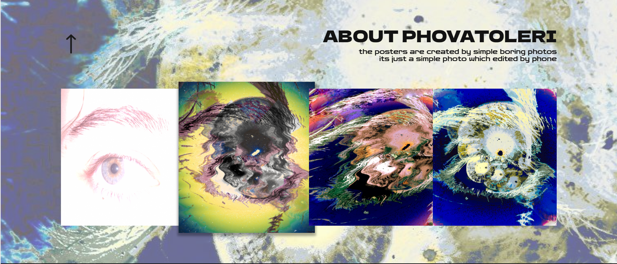
Figure 3.21 – The fourth section on the main page in the online store

<section id="about__us" class="about__us">
<div class="page">
<div class="decor"></div>
<div class="container">
<div class="first__line reveal">
<div class="button__line" type="button"><a href="#header"><img src="/img/header/up-arrow-black.png"></a></div>
<div class="about__us__title">About Phovatoleri</div></div>
<div class="about__us__text reveal">
<div class="about__us__text-1">The Phovatoleri was created in 2020</div>
<div class="about__us__text-2">The posters are created by simple photos which edited by phone</div>
Figure 3.22 – The HTML code for the fourth section (part 1)
</div><div class="about__us-bg"></div>
<div class="about__us__photos">
<div class="about__us__photos-photo1 reveal-photo1"><img src="/img/process/1.png" alt="Photo 1"></div>
<div class="about__us__photos-photo2 reveal-photo2"><img src="/img/process/2.png" alt="Photo 2"></div>
<div class="about__us__photos-photo3 reveal-photo3"><img src="/img/process/3.png" alt="Photo 3"></div>
<div class="about__us__photos-photo4 reveal-photo4"><img src="/img/process/4.png" alt="Photo 4"></div>
</div></div></div>
</section>
Figure 3.23 – The HTML code for the fourth section (part 2)

- Footer: navigation menu (Gallery, War, About us, Cart), social network (Instagram), contact information (gmail) (Fig. 3.24, Fig. 3.25, Fig. 3.26).


Figure 3.24 – The second section on the main page in the online store

<footer class="footer">
<div class="page"><div class="decor__decor"></div>
<div class="container">
<div class="footer__items">
<div class="footer__items-left">
<div class="footer__items-left-title">Contact us</div>
<div class="footer__items-left-social-media">
<a class="footer__items-left-social-media-inst">instagram</a>
<a class="footer__items-left-social-media-email">gmail.com</a>
</div></div>
<div class="footer__items-right">
<a href="/view__all.html" class="footer__items-right-gallery">Gallery</a>
<a href="#war__products" class="footer__items-right-war">War</a>
<a href="#about__us" class="footer__items-right-about-us">About Us</a>
<a href="/cart.html" class="footer__items-right-cart">Cart</a>
</div>
</div>
<div class="footer__items-footer">© phovatoleri 2024</div></div></div></footer>
Figure 3.25 – The HTML code for footer

window.addEventListener('scroll', reveal);
function reveal() {
var reveals = document.querySelectorAll('.reveal, .reveal-photo1, .reveal-photo2, .reveal-photo3, .reveal-photo4');

for(var i = 0; i < reveals.length; i++) {
var windowhength = window.innerHeight;
var revealtop = reveals[i].getBoundingClientRect().top;
var revealpoint = 150;

if (revealtop < windowhength - revealpoint) {
reveals[i].classList.add('active');
}
else {
reveals[i].classList.remove('active');}
}}
Figure 3.26 – The JavaScript code for the whole main page (animation part)

The ready mockup of the main page on the future site which created in the Figma program (Fig. 3.27, Fig. 3.28).
The ready mockup of the gallery page (Fig. 3.29, Fig. 3.30, Fig. 3.31, Fig. 3.32, Fig. 3.33).
The ready mockup of the product page (Fig. 3.34).
The ready mockup of the cart page (Fig. 3.35).
The ready mockup of the order page (Fig. 3.36).

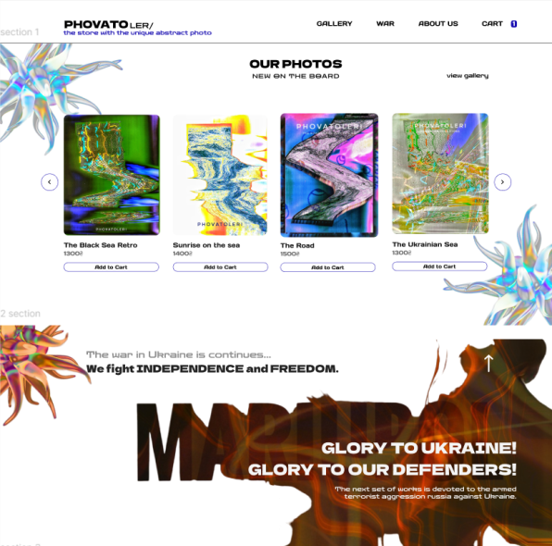
Figure 3.27 – The ready layout of the main page (part 1)
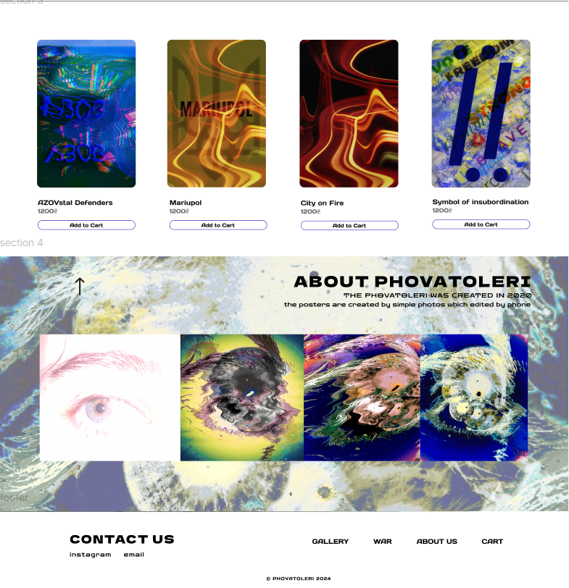
Figure 3.28 - The ready layout of the main page (part 2)

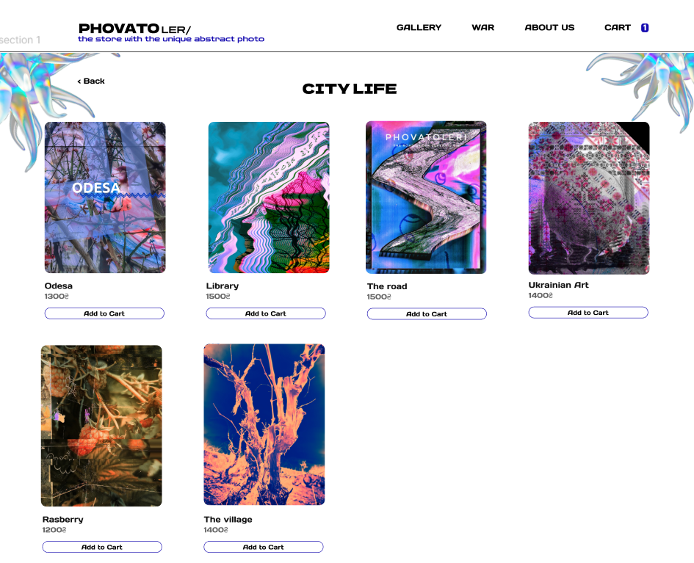
Figure 3.29 - The ready layout of the gallery page (part 1)
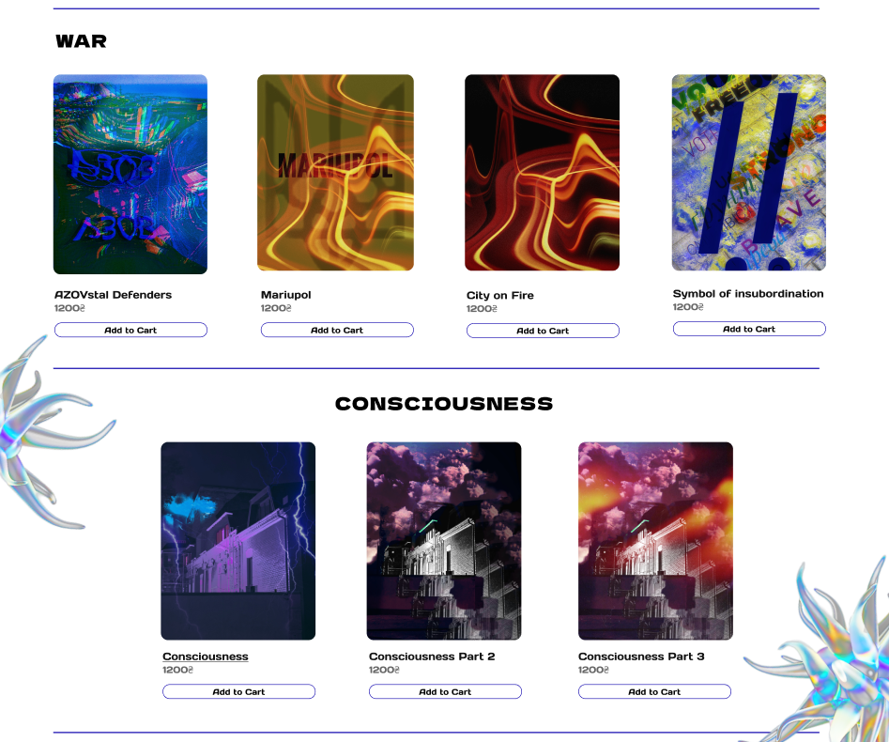
Figure 3.30 - The ready layout of the gallery page (part 2)

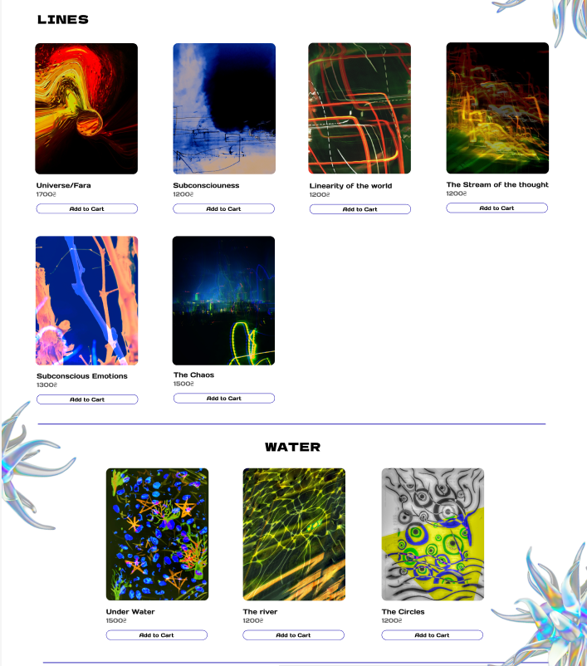
Figure 3.31 - The ready layout of the gallery page (part 3)

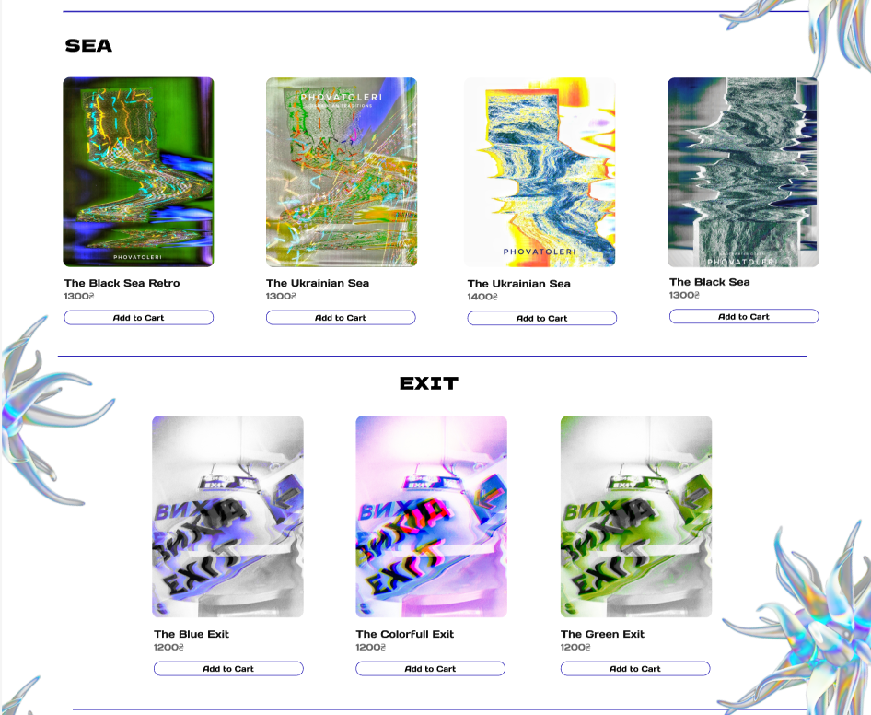
Figure 3.32 - The ready layout of the gallery page (part 4)

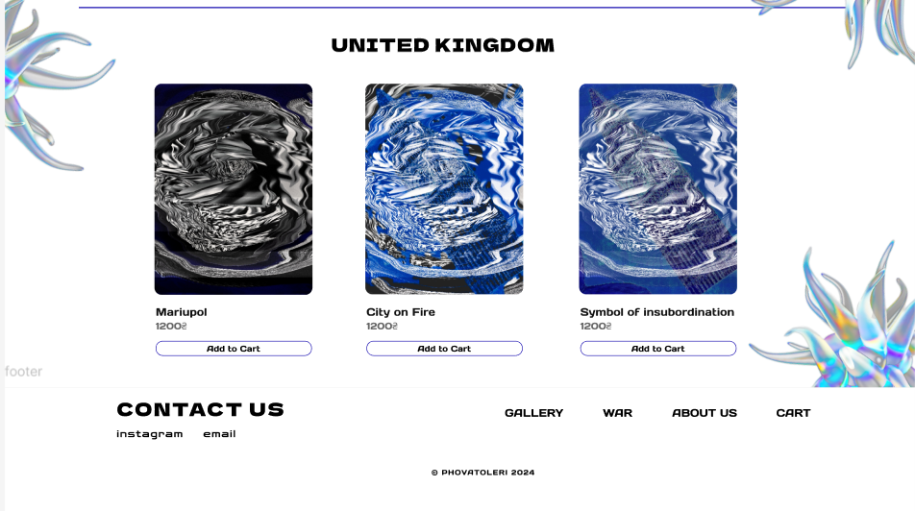
Figure 3.33 - The ready layout of the gallery page (part 5)

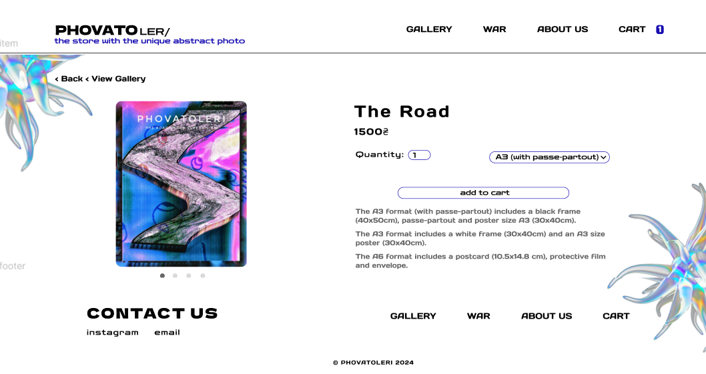
Figure 3.34 - The ready layout of the product page

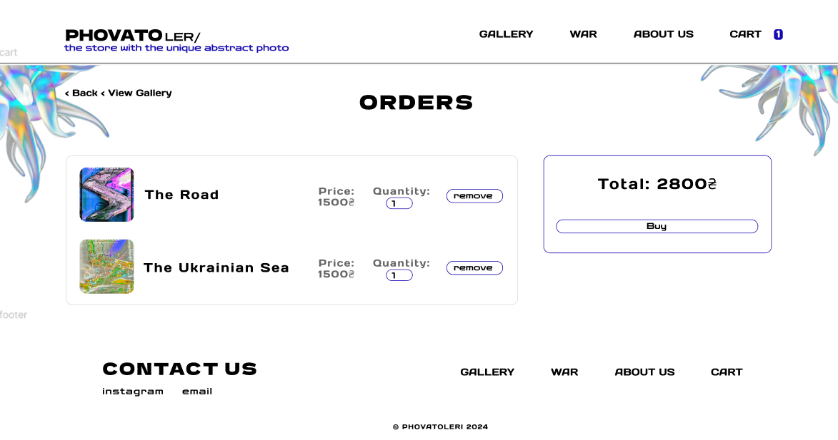
Figure 3.35 - The ready layout of the cart page

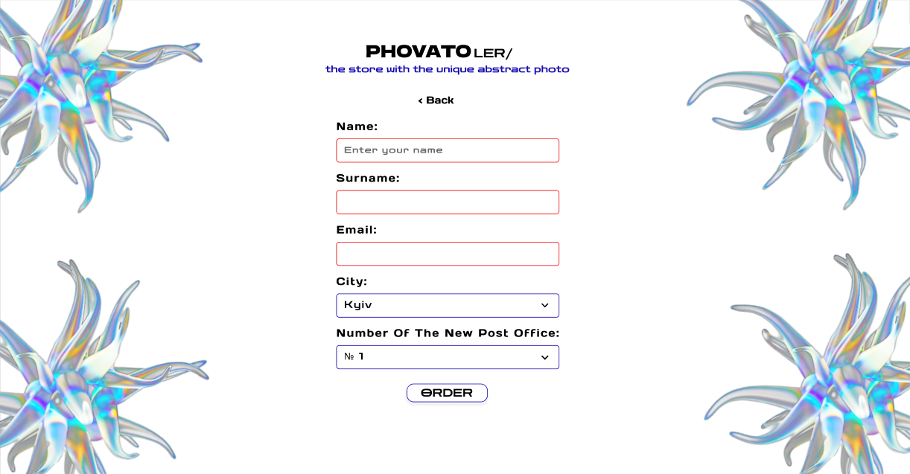
Figure 3.36 - The ready layout of the order page

The whole HTML code is in Appendix B.
The whole CSS code of the main page is in Appendix C.
The whole JavaScript code is in Appendix D.

3.6 Development of online store elements

Separate elements were created for the online store, which emphasize the design and wishes of the customer.
The first element is colored header (Fig. 3.37, Fig. 3.38, Fig. 3.39). When the cursor is in the header field, a highlight appears. The color of the backlight changes relative to the cursor position.

Figure 3.37 – The colored header in the online store

Figure 3.38 – The colored header in the online store

"use strict"
window.addEventListener('load', windowLoad);
function windowLoad() {
if (document.querySelector('[data-glow]')) {
document.documentElement.addEventListener('mouseover', buttonActions);
document.documentElement.addEventListener('mouseout', buttonActions);
document.documentElement.addEventListener('mousemove', buttonActions);

let bGlow, bGlowColor, bGlowSize;

function buttonActions(e) {
const button = e.target.closest('[data-glow]');
if (!button) return;

if (e.type === "mouseover") {
button.insertAdjacentHTML("beforeend", `
<span class="glow"><span class="color"></span></span>`);

bGlow = button.querySelector('.glow');
bGlowColor = button.querySelector('.color');

bGlowSize = Math.min(button.offsetWidth, button.offsetHeight);
bGlow.style.width = bGlow.style.height = `${bGlowSize}px`;

bGlowColor.style.width = `${button.offsetWidth}px`;
bGlowColor.style.height = `${button.offsetHeight}px`;
}
if (e.type === 'mouseout') {
button.querySelector('.glow').remove();
}
if (e.type === 'mousemove') {
const posX = e.pageX - (button.getBoundingClientRect().left - scrollX);
const posY = e.pageY - (button.getBoundingClientRect().top - scrollY);

bGlow.style.left = `${posX - bGlowSize / 2}px`;
bGlow.style.top = `${posY - bGlowSize / 2}px`;

bGlowColor.style.transform = `translate(${posX - (button.offsetWidth - bGlowSize / 2)}px,
${posY - (button.offsetHeight - bGlowSize / 2)}px)`; }}}}
Figure 3.39 – The JavaScript code for colored header animation
The second element is slick slider (Fig. 3.40, Fig. 3.41). The background of the buttons for scrolling the slider is transparent, there is only a colored edge, which allows you to focus more attention on the product itself.

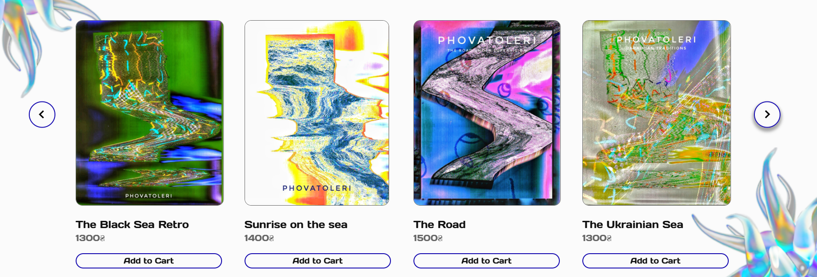
Figure 3.40 – The slick slider in the online store

$(function(){ $('.slider').slick({
slidesToShow: 4,
slidesToScroll: 4,
});});
Figure 3.41 – The JavaScript code, slick slider animation in the online store

The third element is animation for some elements in the header menu and in the footer menu (Fig. 3.42, Fig. 3.43, Fig. 3.44, Fig. 3.45).

Figure 3.42 – The animation in the menu in the online store

&__menu__about__us, &__menu__cart, &__menu__gallery, &__menu__war {
letter-spacing: 1.5px;
display: flex;
&:hover {
text-decoration: 1.5px overline #160bb0;
transform: translateY(-10px);
transition: all 0.3s; }}
Figure 3.43 – The SCSS code, animation in the menu


Figure 3.44 – The animation in the footer in the online store

&-gallery, &-war, &-about-us, &-cart {
color: #040222;
&:hover { text-decoration: 1.5px overline #160bb0;
transform: translateY(-10px);
transition: all 0.3s; }}
Figure 3.45 – The SCSS code, animation in footer

The forth element go to the top of the page using the arrow (Fig. 3.46, Fig. 3.47, Fig. 3.48, Fig. 3.49).


Figure 3.46 – The arrow go to the top of the page in the second section

<div class="button__line" type="button">
<a href="#header">
<img src="/img/header/arrow-up.png">
</a>
</div>
Figure 3.47 – The HTML code, animation in third section


Figure 3.48 – The arrow go to the top of the page in the fourth section

<div class="button__line" type="button">
<a href="#header"><img src="/img/header/up-arrow-black.png"></a>
</div>
Figure 3.49 – The HTML code, animation in fourth section
CONCLUSION AND RECOMMENDATIONS

Analyzed and researched the types of sites, we can conclude that we will create an online store. In this way, the company will be able not only to demonstrate its works, but also to actively sell them. Studied the types of eCommerce websites, it is possible to say that the customer's requirements will suit exactly Online Store Website. I also chose to create a website independently, according to the client's requirements. Since the client wants to achieve a unique minimalistic and concise design with quality images, as this is the main focus of the product. Due to a uniquely crafted design, along with a range of functions, animations, and other features. The future website will stand out from others and have better recognition. After analyzing exactly what type of store will be from the e-commerce side, we can understand that for the company Phovatoleri will be the best these two types of e-commerce: Online Store Websites and Social Media Marketplaces. But the customer wants the creation of a site on which he will sell his products, that is why we choose the Online Store Website type. Since this company currently has a small number of products, Unique digital platforms and Decentralized Commerce, and Product Marketplaces are definitely not suitable for us.
It is recommended to add the ability to choose similar products on the page of a specific product, as well as add other languages ​​to the site - this will help find moe potential customers and the site will become even more convenient for people who do not know English.

